A Project Report on

“RAKSHA – SAFE ROUTE APPLICATION”
Submitted In Partial Fulfillment of the Requirement for the Award of the Degree Of

Bachelor of Technology (Computer Science & Engineering)
Submitted to


Dr. A.P.J. Abdul Kalam Technical University, Uttar Pradesh, Lucknow

Submitted by
Anurag Rana (2203330100036)
Aayush Soam (2203330100005)
Gaurav (2203330100068)
Harishankar Tiwari (2203330100070)

Under the Supervision of

Ms. Deepa Solanki

Designation Department of CSE

Raj Kumar Goel Institute of Technology and Management,Ghaziabad

2025 - 2026

DECLARATION

We, Anurag Rana (2203330100036), Gaurav (2203330100068), Aayush Soam (2203330100005) and Harishankar Tiwari (2203330100070) students of Bachelor of Technology, Computer Science & Engineering department at Raj Kumar Goel Institute of Technology & Management, Ghaziabad hereby declare that the work presented in this project titled “RAKSHA” is outcome of our own work, is bonafide, correct to the best of our knowledge and this work has been carried out taking care engineering ethics. We have completely taken care in acknowledging the contribution of others in this academic work. We further declare that in case of any violation of intellectual property rights or copyrights found at any stage, we as the candidates will be solely responsible for the same.

Place: Ghaziabad (U.P) Anurag Rana (2203330100036) Aayush Soam (2203330100005)
Gaurav (2203330100068)
Harishankar Tiwari (2203330100070)

B.Tech. (CSE)
RKGITM, Ghaziabad

CERTIFICATE

This is to certify that the project report entitled “RAKSHA”, submitted by Anurag Rana (2203330100036), Aayush Soam (2203330100005), Gaurav (2203330100068) and Harishankar Tiwari (2203330100070) in partial fulfillment of the requirement for the award of the degree of Bachelor of Technology in Computer Science & Engineering to Dr. A.P.J. Abdul Kalam Technical University, Uttar Pradesh, Lucknow is a record of student’s own work carried out under our supervision and guidance.

Ms. Deepa Solanki Ms. Nidhi Garg
(Project Guide) (Head of Department)

Department of CSE

ACKNOWLEDGEMENT

The present work will remain incomplete unless we express our feelings of gratitude towards a number of persons who delightfully co-operated with us in the process of this work.
First of all we would like to thank our HOD Ms. Nidhi Garg, RKGITM, Ghaziabad for his encouragement and support during the course of my study. I extend my hearty and sincere gratitude to my project guide, Ms Deepa Solanki, Asst. Prof., Department of Computer Science & Engineering, RKGITM, Ghaziabad for her valuable direction, suggestions and exquisite guidance with ever enthusiastic encouragement ever since the commencement of this project.
This project would not have taken shape, without the guidance provided by project coordinators. Ms.Sarika Tyagi and Ms. Neha Tyagi, who helped in our project and resolved all the technical as well as other problems related to the project and, for always providing us with a helping hand whenever we faced any bottlenecks, inspite of being quite busy with their hectic schedules.

TABLE OF CONTENTS

CHAPTERS PAGE NO.

DECLARATION i
CERTIFICATE ii
ACKNOWLEDGEMENT iii
ABSTRACT iv
LIST OF FIGURES v
LIST OF TABLES vi
CHAPTER I: INTRODUCTION 1-5
  - PROJECT NAME (About the project) 1
  - PREFACE (Background About the project) 2
  - DEFINITION OF PROJECT TECHNOLOGY 4
CHAPTER II: REQUIREMENTS ANALYSIS AND FEASIBILITY STUDY 6-15
  - REQUIREMENTS ANALYSIS 6
    - INFORMATION GATHERING 6
    - FUNCTIONAL REQUIREMENTS 7
    - NON FUNCTIONAL REQUIREMENTS SO ON….
      - HARDWARE REQUIREMENTS
      - SOFTWARE REQUIREMENTS
      - USABILITY REQUIREMENTS
      - SECURITY REQUIREMENTS
  - FEASIBILITY STUDY
    - TECHNICAL FEASIBILITY
    - OPERATIONAL FEASIBILITY
    - ECONOMICAL FEASIBILITY

CHAPTER III: SYSTEM ANALYSIS AND DESIGN
  - SYSTEM ANALYSIS (WITH DESCRIPTION)
  - SYSTEM DESIGN
    - USE CASE DIAGRAM (WITH DESCRIPTION)
    - E-R DIAGRAM (WITH DESCRIPTION)
    - DATA FLOW DIAGRAM (WITH DESCRIPTION)
    - CLASS DIAGRAM (AS PER THE REQUIREMENT OF THE PROJECT & WITH DESCRIPTION)
    - SNAP SHOTS

CHAPTER IV: TESTING

  - ABOUT THE TECHNOLOGY USED
  - TESTING
    - UNIT TESTING
    - INTEGRATION TESTING
    - SYSTEM TESTING

CHAPTER V: ADVANTAGES AND LIMITATIONS OF THE DEVELOPED SYSTEM
  - ADVANTAGES OF DEVELOPED SYSTEM
  - LIMITATIONS OF DEVELOPED SYSTEM

CHAPTER VI: CONCLUSION AND SUGGESTIONS FOR FURTHER WORK
  - CONCLUSION
  - SUGGESTIONS FOR FURTHER WORK

REFERENCES

…........................................................................................................................................................

CHAPTER I: INTRODUCTION
  - PROJECT NAME (About the project) Project Name: Raksha (Safe Route finder)
Raksha is an Android-based personal safety application. Its core function is to provide users with safe navigation routes by analyzing crowdsourced data on potential hazards. Unlike traditional map applications that optimize for the fastest route, Raksha optimizes for safety, allowing users to avoid areas flagged by the community as dangerous, poorly-lit, or isolated. The app is built around a community of verified users who can report and validate safety incidents, creating a dynamic and real-time map of urban safety.

PREFACE (Background About the project)
Public safety remains a significant concern in many urban areas, particularly for women and lone travelers. Standard navigation tools are a missed opportunity in this regard, as they are blind to the nuanced, qualitative differences between two paths. A route that is safe in broad daylight may be a significant risk at night.
The Raksha project was conceived to address this technological gap. The motivation is to create a "community watch" for the digital age, leveraging the collective awareness of a city's residents. By empowering users to share safety information, the app transforms a solitary journey into a connected and informed one. It moves beyond simple "panic button" apps by offering proactive danger avoidance and an automated safety net, aiming to prevent incidents before they occur.

Brief Description
RAKSHA is a comprehensive personal safety mobile application designed to help users travel safely through proactive danger avoidance, real-time emergency alerting, and automated safety mechanisms. The app combines safe route navigation with a dual-channel SOS system (local SMS + cloud-triggered Twilio SMS), a timer-based safety check-in backed by Cloud Functions, proximity alerting using Haversine calculations, a system-level floating panic overlay, live location streaming, a fake call simulator, and home screen widgets for instant access to safety features.
Unlike normal navigation apps, it focuses on user safety, especially for:
- Women
- Students
- Night travelers
- Emergency situations
The application provides the following core safety modules:
1. Emergency SOS System — Dual-channel alert via local SMS and cloud-triggered Twilio SMS with offline resilience via WorkManager.
2. Safety Timer Service — Proactive check-in timer with server-side enforcement via Google Cloud Tasks. Auto-triggers SOS on expiry.
3. Proximity Alert Service — Real-time danger zone alerting during navigation using Haversine distance calculations against crowd-sourced reports.
4. Panic Overlay Service — System-level floating button (TYPE_APPLICATION_OVERLAY) providing instant access to SOS, Fake Call, and Location Share without opening the app.
5. Live Location Sharing — Session-based real-time location streaming via Firestore with shareable deep links and auto-expiry.
6. Fake Call Simulator — Simulates realistic incoming phone calls via AlarmManager with full-screen lock-screen display for escape situations.
7. Crowd-Sourced Danger Reporting — Community-driven incident reports with geo-queries, severity ratings, and map visualization.
8. Safe Zone Finder — Google Places API integration to locate nearby police stations, hospitals, and fire stations.
9. Home Screen Widgets — Jetpack Glance widgets for instant SOS trigger (with 5-second countdown) and adjustable Safety Timer.
10. Route Safety Score — Cross-references route polyline points against known danger reports to calculate a numerical safety score.
The app analyzes multiple factors like crime data, lighting conditions, traffic, and crowd density to recommend a route that minimizes risk.
Example:
Instead of sending you through a dark shortcut, RAKSHA will guide you through a well-lit, crowded, and safer road, even if it is slightly longer.

DEFINITION OF PROJECT TECHNOLOGY
The Raksha application is developed using a modern, scalable, and mobile-first technology stack.
Technology Behind RAKSHA
1. GPS (Global Positioning System)
- Tracks user’s real-time location
- Helps in navigation and route mapping
- Core technology used in all navigation apps
2. Digital Maps & Geospatial Data
- Uses map data (roads, streets, landmarks)
- Data sources:
- OpenStreetMap / Google Maps API
- Includes:
- Roads
- Traffic rules
- Restricted areas
- Navigation apps depend on high-quality map databases for accurate routing

3. Real-Time Data Integration
RAKSHA collects live data such as:
- Traffic conditions
- Accidents
- Crime reports
- Crowd density
Some advanced systems even calculate routes using real-time risk data to avoid accidents or unsafe zones

4. Artificial Intelligence (AI) & Machine Learning
- Predicts unsafe areas
- Learns from past data (crime reports, user feedback)
- Suggests safer routes dynamically
Modern navigation apps use AI to improve accuracy and predict conditions

Frontend (Mobile Client):
      - Language: Kotlin (Official language for modern Android development).
      - UI Toolkit: Jetpack Compose (Android's declarative UI framework for building native interfaces).
      - Maps: Google Maps SDK (For displaying the map, route polylines, and user location).
      - APIs: Google Places API (For destination search and autocomplete).

Backend (Server-Side):
      - Platform: Google Firebase (A Backend-as-a-Service model).
      - Authentication: Firebase Authentication (Handling Google Sign-In and SMS OTP verification).
      - Database: Firebase Firestore (A NoSQL cloud database for storing user profiles, reports, and contacts).
      - Serverless Logic: Firebase Cloud Functions (For running server-side logic like the "Timed Safety Check").

      - Notifications: Firebase Cloud Messaging (For sending proactive danger zone alerts).
- SMS Gateway: Twilio (For programmatic SMS delivery to emergency contacts via Cloud Functions).
- Task Scheduling: Google Cloud Tasks (For scheduling deferred timer expiry checks on the server side).
- Background Work: WorkManager (For offline-resilient SOS queuing with network constraints).
- Home Screen Widgets: Jetpack Glance (For building SOS and Timer home screen widgets).
- Location Services: FusedLocationProviderClient (For battery-optimized GPS tracking).
- Local Storage: Jetpack DataStore (For persistent key-value user preferences storage).
- Deep Linking: Firebase Hosting + App Links (For shareable live location session URLs).

Architecture:
      - Pattern: Clean Architecture (MVVM) with Data, Domain, and Presentation layers.
      - Dependency Injection: Hilt (For managing dependencies and decoupling components)

Services Layer:
The application includes 5 Android Services, 1 Manager, and 1 Worker:
- TimerService — Foreground service (foregroundServiceType="location") maintaining countdown timer with GPS tracking every 30 seconds.
- ProximityAlertService — Foreground service monitoring user position against crowd-sourced danger zones with multi-tier Haversine distance alerts (500m, 200m, 100m).
- LiveLocationService — Foreground service streaming GPS coordinates to Firestore every 5 seconds for real-time location sharing sessions.
- PanicOverlayService — Foreground service (foregroundServiceType="specialUse") rendering a draggable floating button on top of all applications.
- RakshaMessagingService — Firebase Cloud Messaging service for receiving push notifications.
- SosManager — Singleton orchestrator for multi-channel emergency alert dispatch (local SMS + Firestore + WorkManager fallback).
- SosWorker — WorkManager worker for offline-resilient Firestore SOS writes with CONNECTED network constraint.

1. High-Level Architecture Overview
User (Mobile App)
↓
Frontend (UI + Navigation)
↓
Backend Server (Logic + APIs)
↓
Database + External Services
2. Client Layer (Frontend / Mobile App)
This is the user interface layer where users interact with the app.
🔹 Components:
- Login / Signup screen
- Map interface
- Route selection screen
- SOS button & emergency features
🔹 Technologies:
- Android (Java / Kotlin) or Flutter
- Maps SDK (Google Maps API)
🔹 Responsibilities:
- Capture user input (source, destination)
- Display safest route on map
- Show alerts and notifications
Security Layer
- User authentication (Login/OTP)
- Data encryption (HTTPS)
- Secure API communication

Types of Notifications & Alerts
1. Danger Zone Alerts
- Notifies when user enters a high-risk or crime-prone area
- Based on crime data & past incidents
Example:
“ You are entering a low-safety zone. Stay alert or choose an alternate route.”

2. Night Safety Alerts
- Activated during night hours
- Warns about:
  - Dark streets
  - Low crowd areas

3. Traffic & Route Alerts
- Real-time updates about:
  - Traffic jams
  - Roadblocks
  - Accidents
Suggests safer alternative routes

4. Route Deviation Alert
- Triggered when user moves away from the suggested safe path
Example:
“You are off the safe route. Re-routing to a safer path.”

5. SOS Emergency Alert
- Activated when user presses SOS button
Features:
- Sends live location to emergency contacts
- Can notify nearby users/police (future scope)
- Continuous tracking until stopped

6. Live Tracking Notifications
- Notifies trusted contacts:
  - “User has started journey”
  - “User reached destination safely”

7. Real-Time Risk Alerts
- Based on:
  - Sudden crime reports
  - Unsafe crowd behavior
  - Accidents

How Notification System Works
Step-by-Step Flow:
- User starts navigation
- App continuously tracks location (GPS)
- Backend analyzes:
  - Route safety
  - Real-time data
- If risk detected → alert triggered
- Notification sent instantly to user

Technologies Used
1. Push Notification Services
- Firebase Cloud Messaging (FCM)
- Sends real-time alerts to users

2. GPS Tracking
- Tracks user location continuously

3. ☁️ Backend Server
- Processes risk data
- Decides when to trigger alerts

4. AI/ML Models
- Predict unsafe conditions
- Improve alert accuracy over time

5. Real-Time Data APIs
- Traffic data
- Crime data
- Weather (optional)

Security & Privacy
- Alerts sent only to authorized contacts
- User controls:
  - Who receives SOS
  - When tracking is active

Advantages of Notification System
- Enhances real-time safety
- Provides instant warnings
- Helps avoid risky areas
- Supports emergency response
- Builds user confidence

. Firebase Cloud Messaging (For sending proactive danger zone alerts).

CHAPTER II: REQUIREMENTS ANALYSIS AND FEASIBILITY STUDY

REQUIREMENTS ANALYSIS

INFORMATION GATHERING
Project requirements were determined through two primary methods:
- Competitor Analysis: A review of existing safety apps (e.g., Safetipin, Citizen) was conducted to identify common features, discover feature gaps, and establish a baseline for user expectations. This analysis revealed a gap in apps that successfully combine proactive safer routing with automated safety-net features.
- User Surveys (Informal): Discussions with the target demographic were held to identify key concerns. The most requested features were reliable information on "unsafe" areas and an automatic alert system in case the user is incapacitated.

FUNCTIONAL REQUIREMENTS
- FR-1: The system shall allow a user to register and log in via their Google account.
- FR-2: The system shall verify a user's authenticity via SMS OTP.
- FR-3: The user shall be able to add, view, and remove Emergency Contacts from their profile.
- FR-4: The system shall display a map with the user's real-time GPS location.
- FR-5: The system shall allow users to search for a destination.
- FR-6: The system shall display community-reported danger zones on the map.
- FR-7: The system shall generate a route to the destination that avoids high-severity danger zones.
- FR-8: Verified users shall be able to submit an incident report, including location, incident type, severity, and a description.
- FR-9: The user shall be able to start a server-side "Timed Safety Check" timer.
- FR-10: The system shall automatically send an SOS alert to emergency contacts if the user fails to respond to the timer's expiration.
- FR-11: The user shall be able to trigger a manual SOS alert.
FR-12: The system shall provide an offline SOS failsafe using WorkManager that queues Firestore writes when network is unavailable and retries when connectivity is restored.
FR-13: The system shall send SOS alerts via both local Android SMS and cloud-triggered Twilio SMS through Cloud Functions for dual-channel delivery.
FR-14: The system shall provide a floating Panic Overlay button (system-level overlay) that persists on top of all applications, allowing instant access to SOS (via long press), Fake Call, and Location Sharing.
FR-15: The user shall be able to schedule a Fake Call with a configurable delay and caller identity, which displays a full-screen incoming call simulation even on the lock screen.
FR-16: The system shall provide real-time Live Location Sharing via Firestore sessions with shareable deep links (https and custom raksha:// scheme), auto-expiry, and a viewer screen showing a polyline trail on Google Maps.
FR-17: The system shall monitor the user's proximity to crowd-sourced danger zones during navigation using Haversine distance calculations, with three alert tiers: Far (500m), Near (200m), and Critical (100m).
FR-18: The system shall provide Jetpack Glance home screen widgets: an SOS Widget with a 5-second cancellation countdown and a Timer Widget with adjustable duration (5-120 minutes).
FR-19: The system shall display nearby Safe Zones (police stations, hospitals, fire stations) within a 5km radius using the Google Places Nearby Search API.
FR-20: The system shall calculate and display a Route Safety Score by cross-referencing decoded route polyline points against known danger reports within 500 meters.
FR-21: The user shall be able to store Medical ID information (blood group, allergies, medical conditions, emergency note) accessible via a persistent notification.
FR-22: The system shall enforce server-side timer expiry via Google Cloud Tasks, ensuring SOS alerts are dispatched even if the user's device loses power or connectivity.

NON FUNCTIONAL REQUIREMENTS
      - HARDWARE REQUIREMENTS

        - An Android smartphone with Android 8.0 (Oreo) or newer.
        - Functional GPS chip for location services.
        - Active internet connection (Mobile Data or Wi-Fi).

SOFTWARE REQUIREMENTS
        - Android Operating System (8.0+).
        - Google Play Services (for Maps and Auth).
        - Development: Android Studio, Kotlin JDK 1.9+, Firebase CLI, Node.js (for Cloud Functions).
Server-Side: Firebase Cloud Functions (Gen 2, Node.js), Google Cloud Tasks, Twilio SMS API account.
APIs: Google Maps SDK, Google Places API, Google Directions API, Firebase Cloud Messaging.

USABILITY REQUIREMENTS
        - The UI must be simple, high-contrast, and intuitive, especially for use in high-stress situations.
        - Critical features (e.g., manual SOS) must be accessible within two taps.
        - The application must have a clear onboarding flow for new users.

SECURITY REQUIREMENTS
        - All data transmitted between the app and Firebase must be over SSL.
        - User authentication must be managed by Firebase Authentication (OAuth 2.0).
        - Incident reporting shall be restricted to SMS-verified users to mitigate false reports.

FEASIBILITY STUDY

    - TECHNICAL FEASIBILITY
The project is technically feasible. All core components (Kotlin, Jetpack Compose, Firebase, Google Maps SDK) are mature, stable, and well-documented technologies provided by Google. The most complex feature, the server-side timer, is a standard implementation for Firebase Cloud Functions. No unproven technology is required.

OPERATIONAL FEASIBILITY
The project is operationally feasible. Its success hinges on user adoption and community participation. The primary operational challenge is the "cold start" problem, where the app has no report data in a new city. This will be overcome by initial marketing and community-building efforts to gather a baseline of reports.

ECONOMICAL FEASIBILITY
The project is highly feasible from an economic standpoint. Development tools (Android Studio, Kotlin)
are free. Firebase and Google Maps Platform both offer generous perpetual free tiers that are more than
sufficient for development, testing, and supporting a significant initial user bas

CHAPTER III: SYSTEM ANALYSIS AND DESIGN

SYSTEM ANALYSIS (WITH DESCRIPTION)
The system is designed as a native Android client interacting with a serverless Firebase backend, augmented by Google Cloud Tasks for deferred execution and Twilio for SMS delivery. The application's internal structure follows the principles of Clean Architecture, which separates concerns into four distinct layers:
- Presentation Layer (UI): Consists of Jetpack Compose screens and ViewModels. It is responsible for displaying state to the user and capturing input.
- Domain Layer (Business Logic): Contains Use Cases (e.g., GoogleSignInUseCase) and Repository Interfaces (e.g., AuthRepository). This layer defines the core business rules and is independent of the UI and database.
- Data Layer (Data Sources): Consists of Repository Implementations (e.g., AuthRepositoryImpl) that manage the actual data operations by communicating with Firebase (Firestore, Auth) and local DataStore.
Services Layer (Background Services): Contains 5 Android Services (TimerService, ProximityAlertService, LiveLocationService, PanicOverlayService, RakshaMessagingService), 1 Manager (SosManager for multi-channel SOS dispatch orchestration), and 1 Worker (SosWorker for offline-resilient Firestore writes via WorkManager). This layer handles long-running background operations, location tracking, and system-level overlays.
This decoupled architecture, connected via Hilt (Dependency Injection), makes the app scalable, testable, and maintainable.

SYSTEM DESIGN
    - USE CASE DIAGRAM (WITH DESCRIPTION)
The Use Case diagram illustrates the interactions between the user and the Raksha system. The primary actor is the User. The main use cases include: Login with Google, Verify Phone, Manage Emergency Contacts, Request Safe Route, Report Incident, Start Timed Safety Check, Trigger Manual SOS, Enable Panic Overlay, Schedule Fake Call, Share Live Location, View Safe Zones, Use Home Screen Widgets, and Store Medical ID. An external actor, Emergency Contact, receives SOS Alerts (via SMS, Twilio, and FCM push notifications) and can view shared live location sessions. The Cloud System actor (Firebase + Cloud Tasks + Twilio) handles server-side timer enforcement, notification dispatch, and SMS delivery.

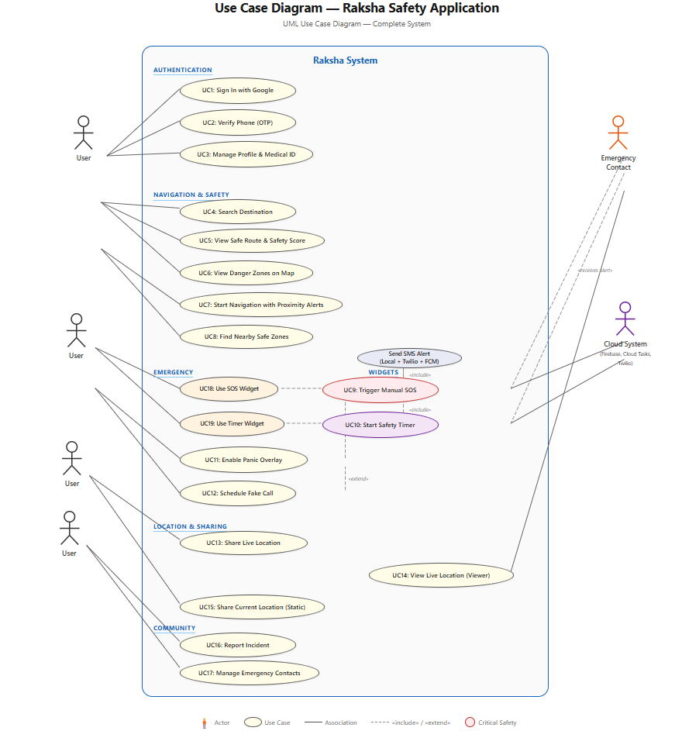

Fig 3.1

Actors in RAKSHA System

1. User (Primary Actor)
- Person using the app for safe navigation
2. Emergency Contact
- Receives alerts & live location
3. Admin (Optional Actor)
- Manages data (crime data, user reports, system updates)

Main Use Cases
1. Register / Login
- User creates account or logs in

2. Enter Source & Destination
- User inputs starting and ending location

3. View Safest Route
- System calculates and displays safest path

4. Start Navigation
- Provides real-time directions

5. Receive Alerts
- User gets notifications:
  - Danger zone
  - Traffic
  - Route deviation

6. Trigger SOS
- User presses emergency button
Includes:
- Send location to contacts
- Start live tracking

7. Share Live Location
- User shares journey status with trusted contacts

8. Provide Feedback
- User reports unsafe areas or gives ratings

9. Manage Data (Admin)
- Admin updates:
  - Crime data

E-R DIAGRAM (WITH DESCRIPTION)
The E-R diagram outlines the database structure in Firestore.
1. User
Stores information about app users
Attributes:
- User_ID (Primary Key)
- Name
- Email
- Phone
- Password
- Emergency_Contact_ID

2. Route
Represents routes generated by the system
Attributes:
- Route_ID (Primary Key)
- Source
- Destination
- Distance
- Estimated_Time
- Safety_Score

3. Alert
Stores all notifications and alerts
Attributes:
- Alert_ID (Primary Key)
- Alert_Type (Danger / Traffic / SOS)
- Message
- Timestamp
- User_ID (Foreign Key)
4. Emergency Contact
Stores trusted contacts for SOS
Attributes:
- Contact_ID (Primary Key)
- Name
- Phone
- Relationship
- User_ID (Foreign Key)

5. Crime Data
Used to calculate safety of routes
🔹 Attributes:
- Crime_ID (Primary Key)
- Location
- Crime_Type
- Risk_Level
- Date

6. Feedback
User feedback about routes or safety
Attributes:
- Feedback_ID (Primary Key)
- User_ID (Foreign Key)
- Route_ID (Foreign Key)
- Rating
- Comments

7. SOS Alert
Stores emergency SOS alert records
Attributes:

Alert_ID (Primary Key)
User_ID (Foreign Key)
Timestamp
Status (ACTIVE / RESOLVED)
Last_Location (GeoPoint)
Alert_Dispatched (Boolean)

8. Active Timer
Stores currently running safety timer sessions
Attributes:

Timer_ID (current)
User_ID (Foreign Key)
Start_Time (epoch ms)
Expiry_Time (epoch ms)
Duration_Minutes
Is_Canceled (Boolean)
Last_Location (GeoPoint)
Cloud_Task_Name (String)
Alert_Triggered (Boolean)

9. Live Location Session
Stores real-time location sharing sessions
Attributes:

Session_ID (Primary Key, UUID)
Host_User_ID (Foreign Key)
Host_Name
Is_Active (Boolean)
Expires_At (epoch ms)
Start_Time (epoch ms)
Locations (subcollection: lat, lng, timestamp, speed)

10. Safety Tip
Stores context-aware safety tips
Attributes:

Tip_ID (Primary Key)
Content (String)
Time_Tag (morning/commute/night/day)
Active (Boolean)

Relationships Between Entities
1. User → Route
- Relationship: Searches / Uses
- Type: One-to-Many (1:N)
One user can search multiple routes

2. User → Alert
- Relationship: Receives
- Type: One-to-Many (1:N)
One user receives many alerts

3. User → Emergency Contact
- Relationship: Has
- Type: One-to-Many (1:N)
One user can have multiple emergency contacts

4. Route → Crime Data
- Relationship: Analyzed By
- Type: Many-to-Many (M:N)
One route may pass through multiple crime zones
One crime location may affect multiple routes

5. User → Feedback
- Relationship: Gives
- Type: One-to-Many (1:N)

6. Route → Feedback
- Relationship: Receives
- Type: One-to-Many (1:N)

7. Alert → User
- Relationship: Sent To
- Already defined via foreign key

ER Diagram Representation

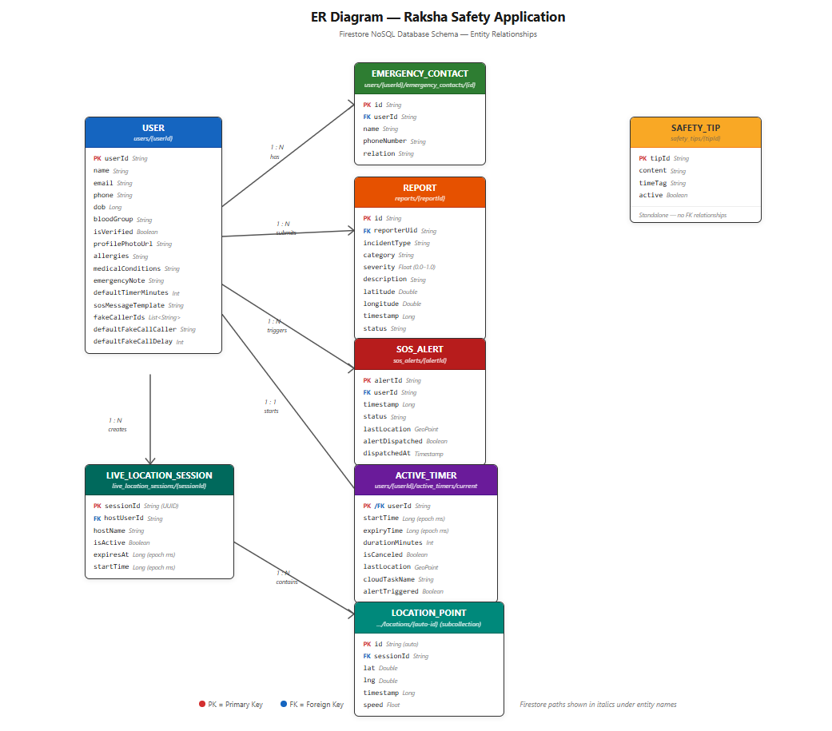

Fig 3.2

DATA FLOW DIAGRAM (WITH DESCRIPTION)
The DFD shows the movement of data. At Level 0 (Context Diagram), the Raksha System receives Login Details, Route Requests, and Incident Reports from the User. It sends Safe Routes and Alerts back to the User, and SOS Alerts to the Emergency Contact. At Level 1, data flows between processes like Manage Authentication, Generate Safe Route, and Store Incident Report, and data stores like User_Store and Reports_Store.

DFD Level 0 Diagram

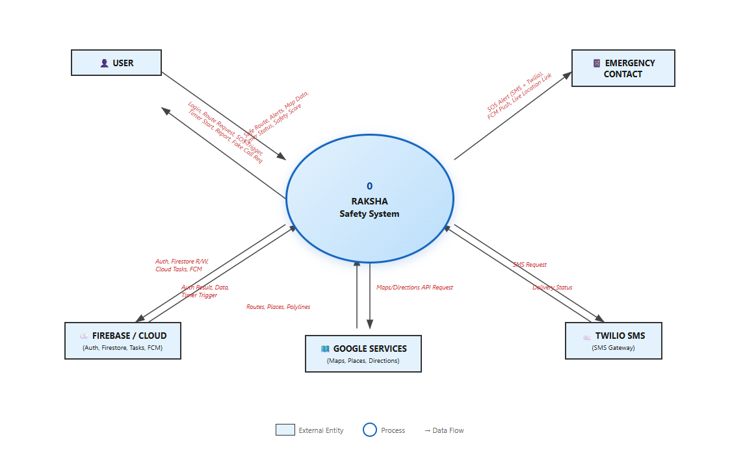

Fig 3.3

DFD Level 1 Diagram

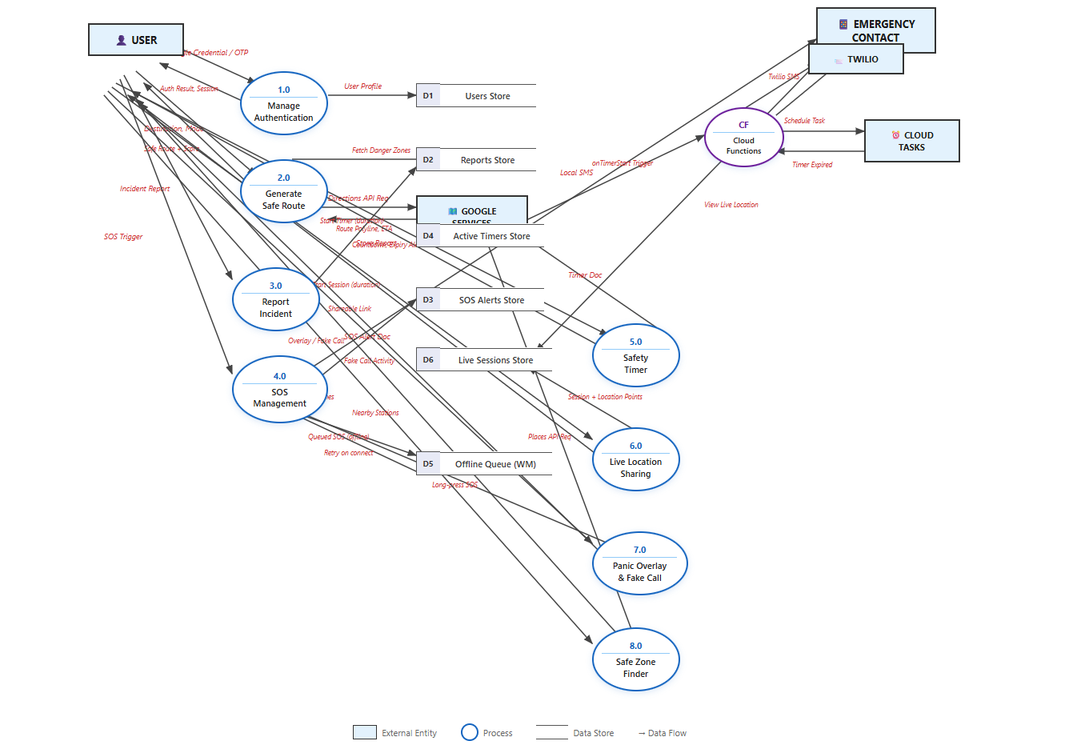

Fig 3.4

CLASS DIAGRAM (WITH DESCRIPTION)
The Class Diagram illustrates the Clean Architecture principles. For the authentication feature:
      - AuthenticationScreen (UI) depends on AuthViewModel.
      - AuthViewModel (Presentation) depends on GoogleSignInUseCase.
      - GoogleSignInUseCase (Domain) depends on the AuthRepository (Interface).
      - AuthRepositoryImpl (Data) implements AuthRepository and depends on FirebaseAuth. This demonstrates the Dependency Inversion Principle, where high-level modules (UI) do not depend on low-level modules (Data).

Main Classes in RAKSHA System
1. User Class
Attributes:
- userId
- name
- email
- phone
- password
Methods:
- register()
- login()
- enterDestination()
- viewRoute()
- triggerSOS()

2. Route Class
Attributes:
- routeId
- source
- destination
- distance
- estimatedTime
- safetyScore
Methods:
- calculateRoute()
- getSafeRoute()
- updateRoute()

3.Alert Class
Attributes:
- alertId
- alertType
- message
- timestamp
Methods:
- sendAlert()
- generateAlert()

4. EmergencyContact Class
Attributes:
- contactId
- name
- phone
- relation
Methods:
- addContact()
- removeContact()
- notifyContact()

5. CrimeData Class
Attributes:
- crimeId
- location
- crimeType
- riskLevel
- date
Methods:
- fetchCrimeData()
- updateCrimeData()

6. Feedback Class
Attributes:
- feedbackId
- rating
- comments
Methods:
- submitFeedback()
- updateFeedback()
7. NavigationSystem Class
Attributes:
- currentLocation
- destination
- routeList
Methods:
- findRoutes()
- calculateSafetyScore()
- suggestSafeRoute()

Relationships Between Classes
Association
- User ↔ Route
User selects and views routes

Aggregation
- User ◇── EmergencyContact
Contacts exist independently but linked to user

Composition
- Route ◆── Alert
Alerts depend on route/navigation

Dependency
- NavigationSystem → CrimeData
Uses crime data to calculate safety

Inheritance (Optional Design)
- Alert → DangerAlert / TrafficAlert / SOSAlert
Specialized alert types

8. SosManager Class

Attributes:
- fusedLocationClient
- firestore
- context
- Methods:
- sendSosToAllContacts(triggerCloudSos: Boolean)
- getEmergencyContacts(): List<EmergencyContact>
- enqueueSosWorker(lat, lng)

9. TimerService Class (Foreground Service)
Attributes:
- countdownTimer
- remainingTime: StateFlow<Long>
- locationRequest
Methods:
- startLocalCountdown(durationMs)
- handleTimerExpired()
- updateNotification(remainingMs)

10. PanicOverlayService Class (Foreground Service)
Attributes:
- layoutParams (TYPE_APPLICATION_OVERLAY)
- windowManager
Methods:
- onStartCommand() — creates floating button
- handleLongPressSos()
- handleFakeCallTrigger()
- handleLocationShare()

11. LiveLocationService Class (Foreground Service)
Attributes:
- sessionId
- expiresAt
Methods:
- createSession(durationMinutes)
- streamLocationUpdates()
- checkExpiry()

12. FakeCallViewModel Class
Attributes:
- callerEntries: List<CallerEntry>
- selectedCaller
- delaySeconds
Methods:
- scheduleFakeCall(context, callerName, callerPhone, delaySec)
- scheduleFakeCallFromContext() — uses default caller from DataStore

13. SosWorker Class (WorkManager)
Attributes:
- firestore (injected via HiltWorker)
Methods:
- doWork() — writes SOS alert to Firestore when network is available

SNAP SHOTS

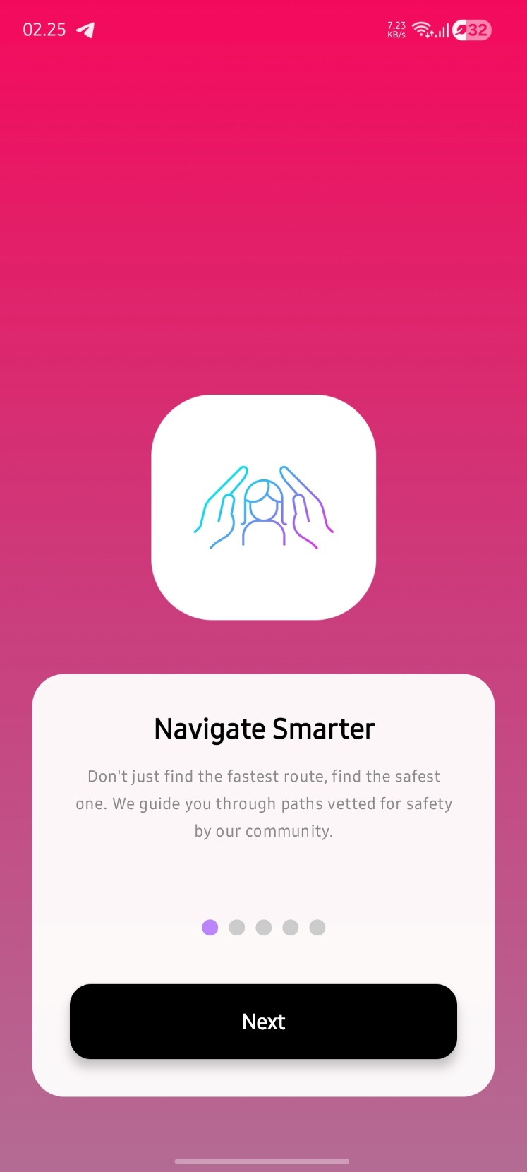 Fig 3.4.1 (On Boarding Screen 1)
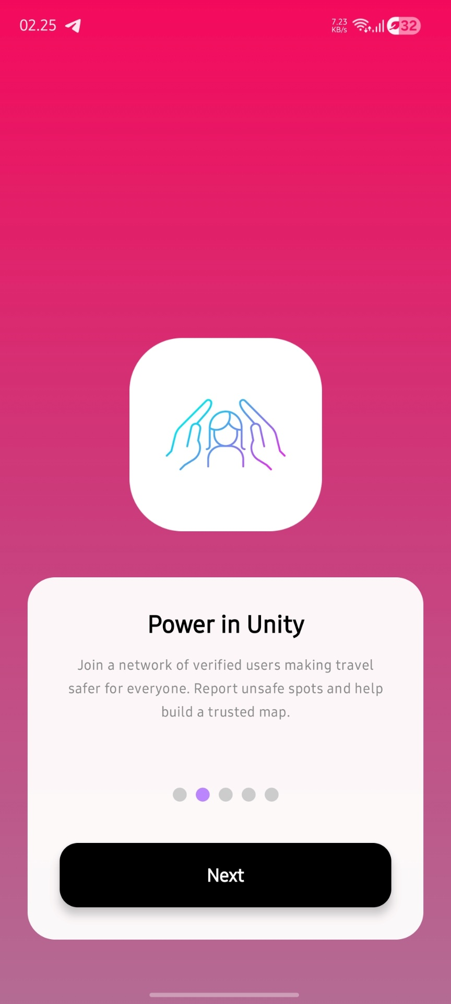 Fig 3.4.2 (On Boarding Screen 2)

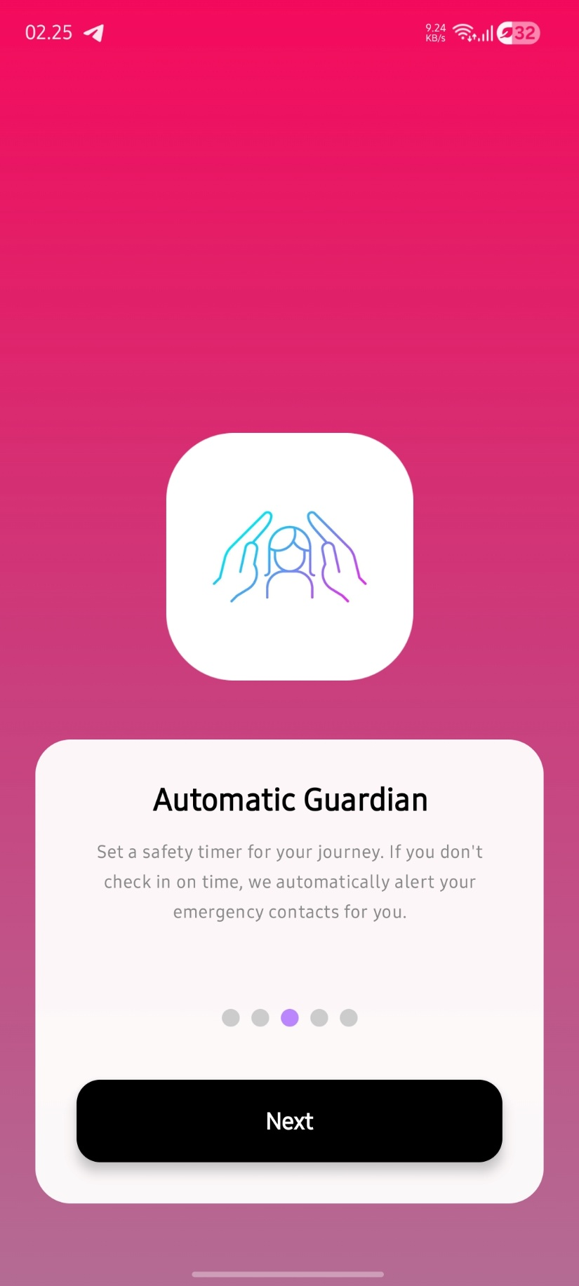 Fig 3.4.3 (On Boarding Screen 3)

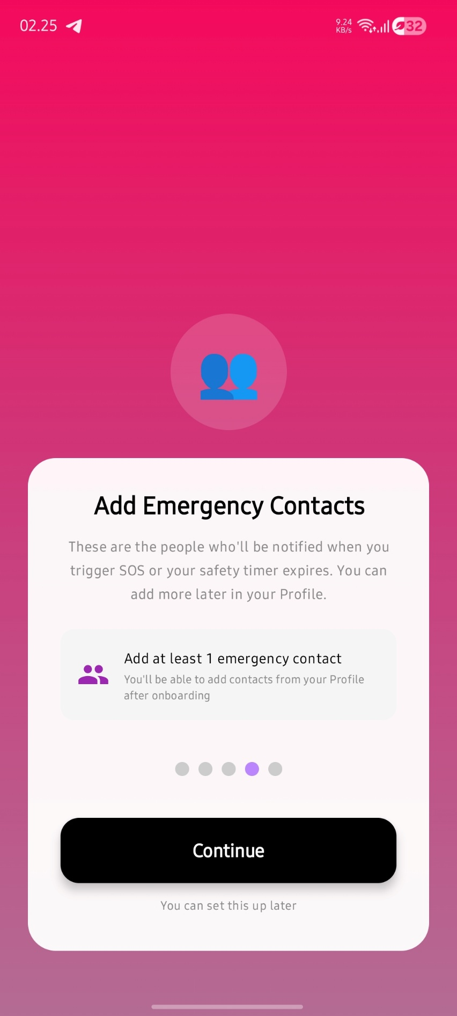 Fig 3.4.4 (On Boarding Screen 4)

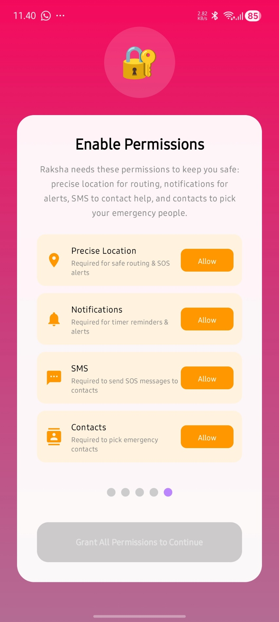 Fig 3.4.5 (On Boarding Screen 5)

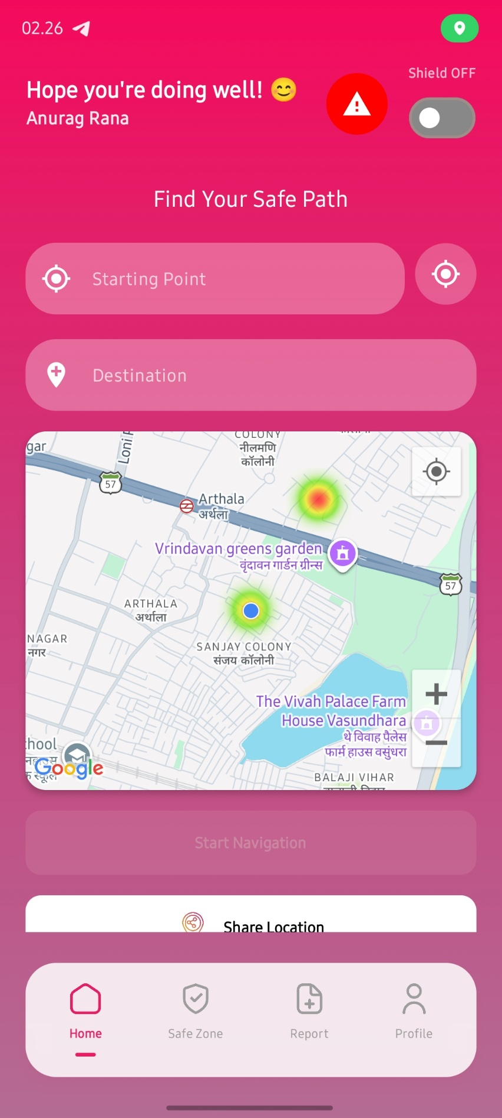 Fig 3.5.1 (Home Screen Part-1)
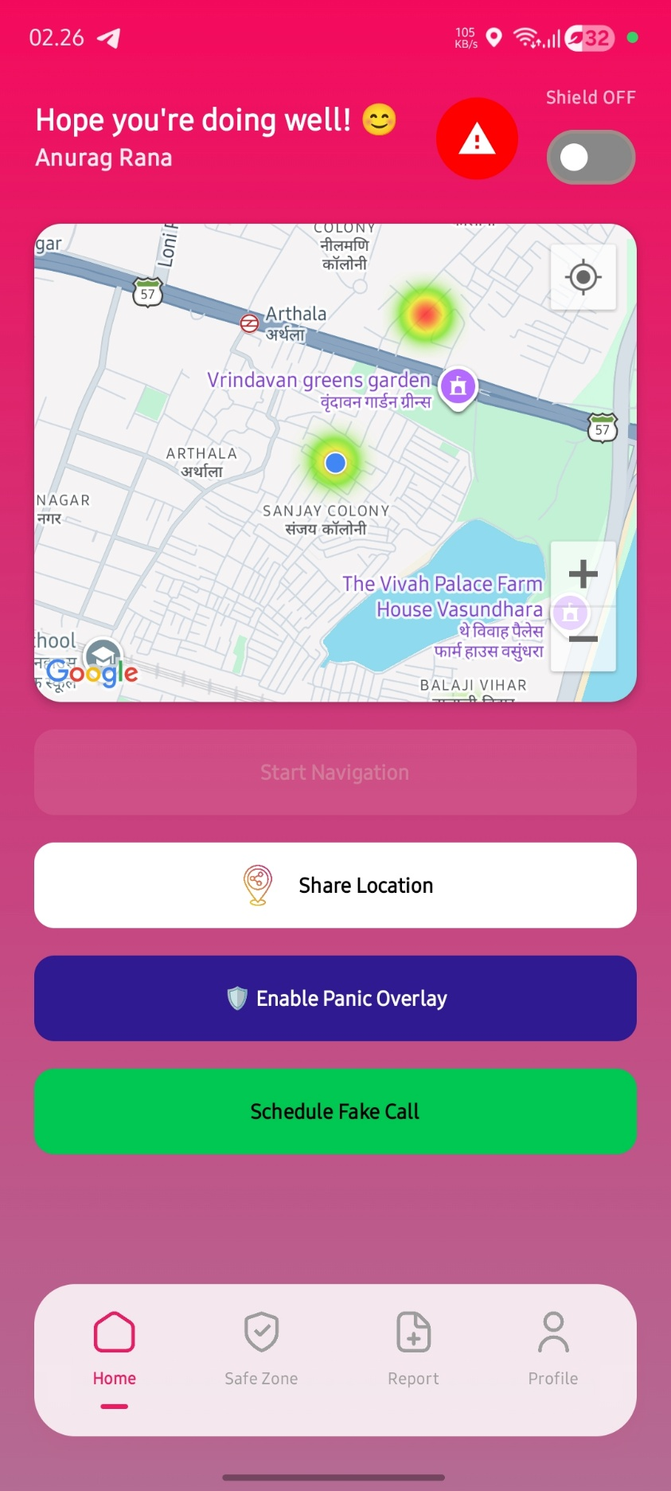 Fig 3.5.2 (Home Screen Part-2)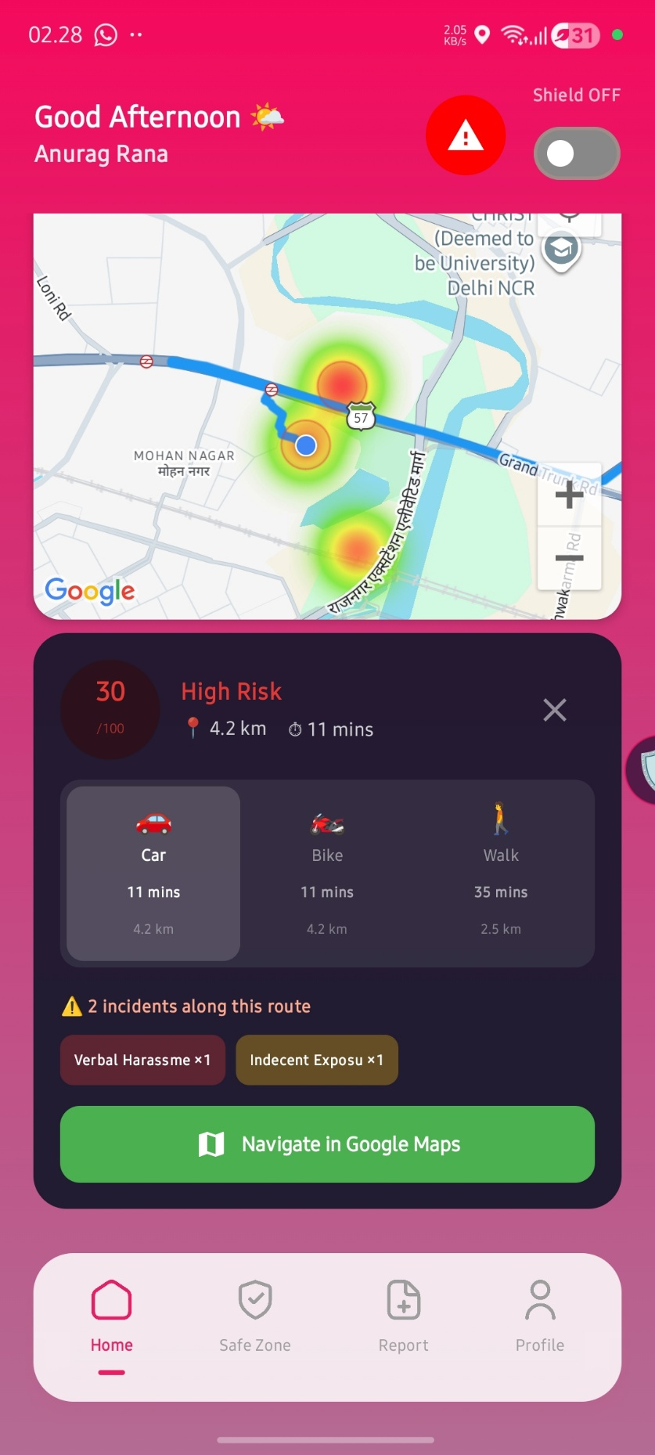 Fig 3.5.1 (Home Screen Part-3 Navigation)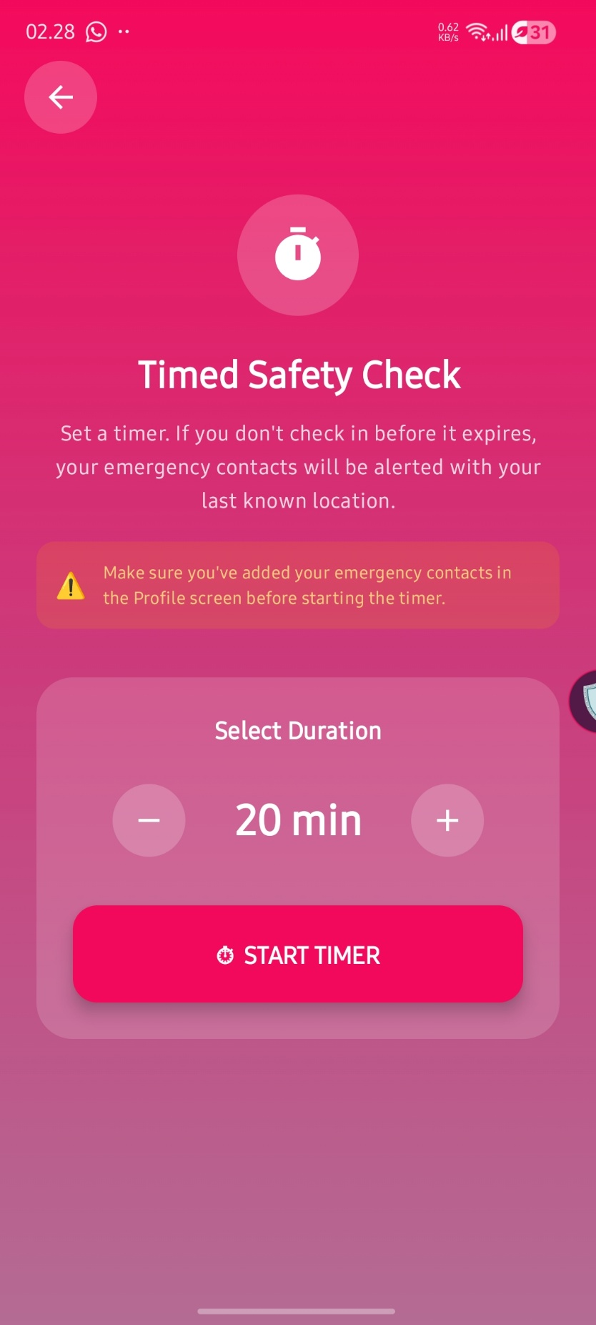 Fig 3.6.1 (Safety Timer Screen)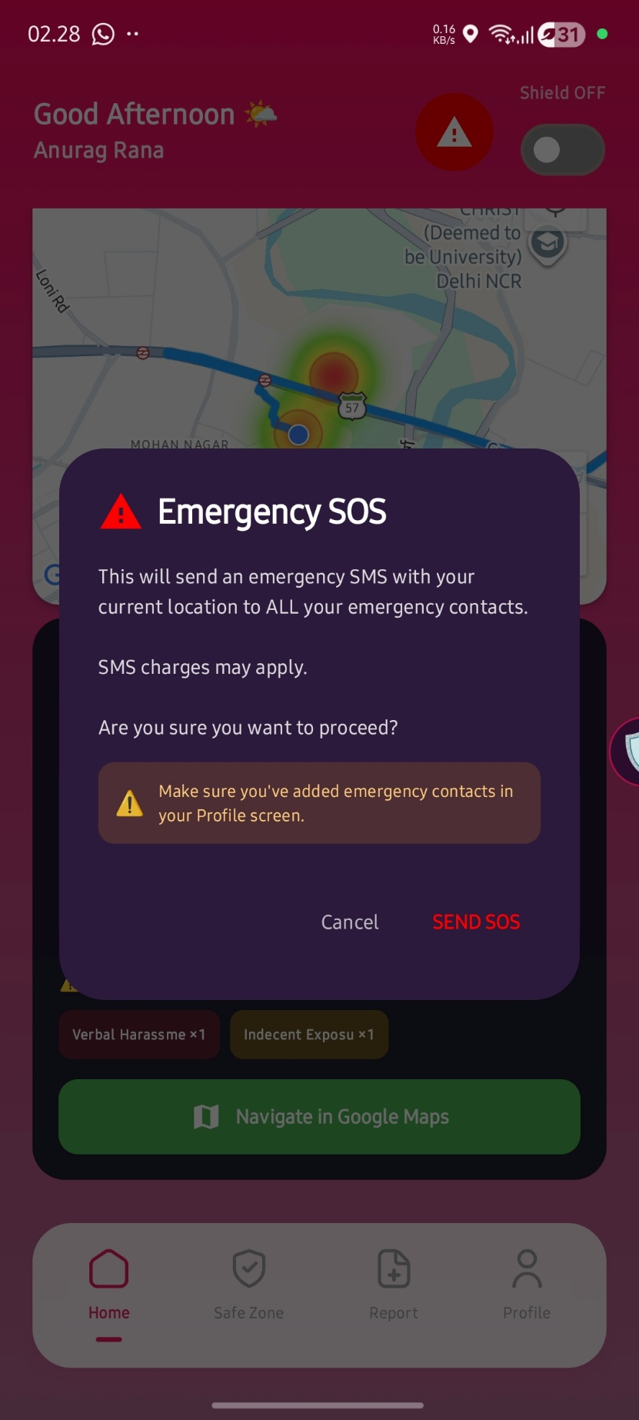 Fig 3.7.1 (Send SOS Dialog Box)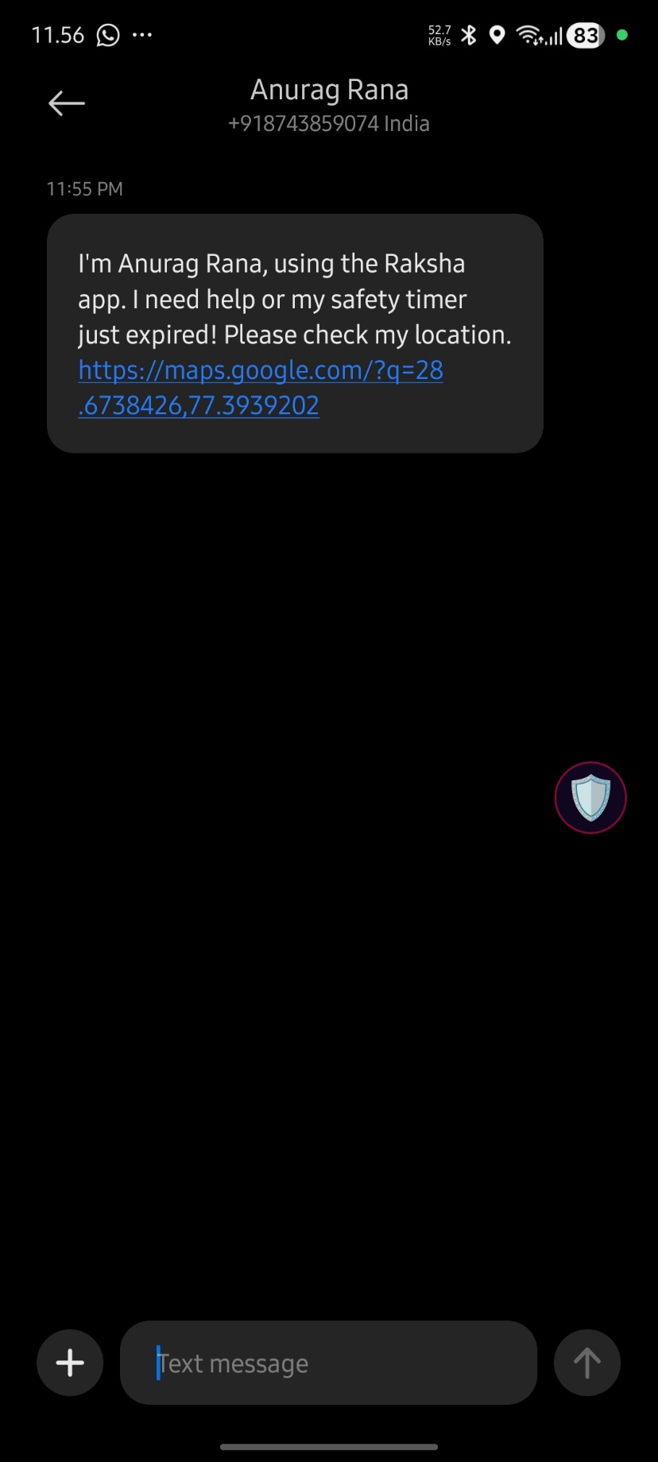 Fig 3.7.2 (SOS Message sent natively)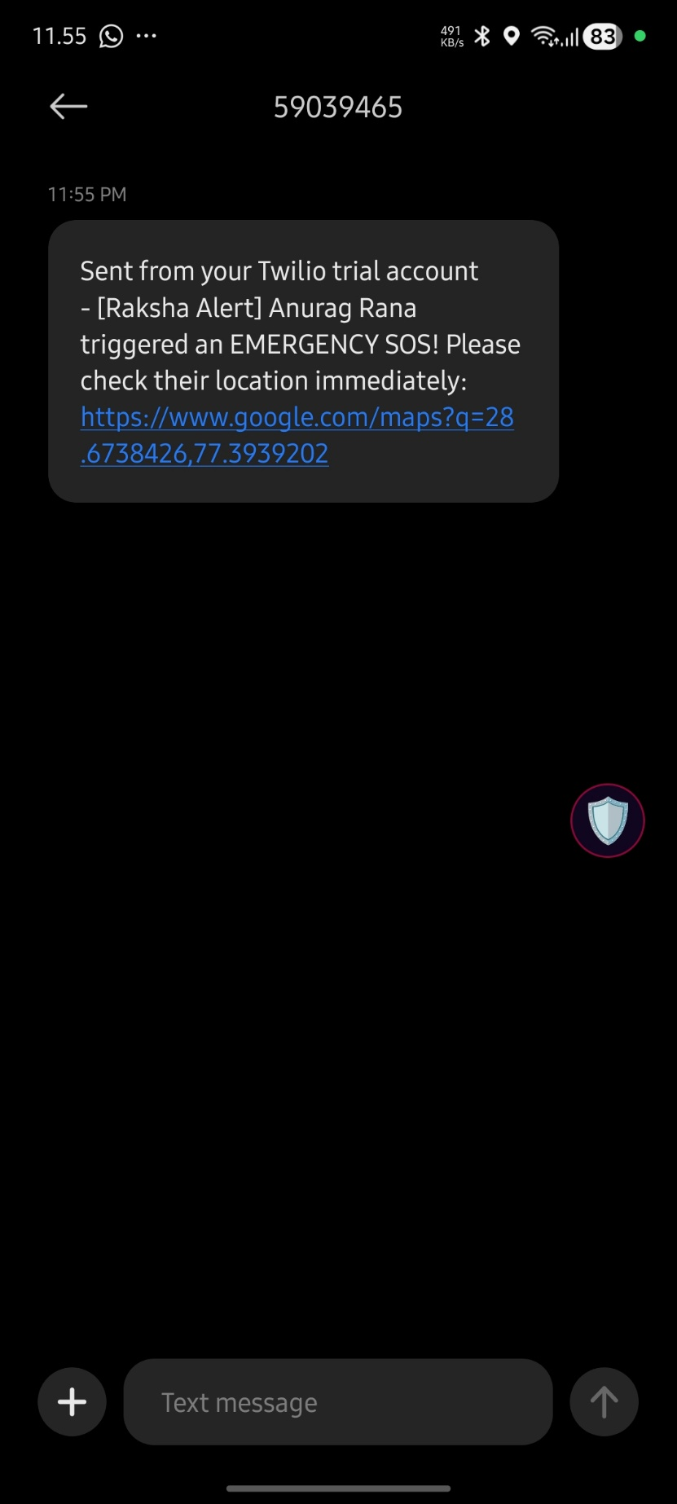 Fig 3.7.3 (SMS Message sent via Twilio API) 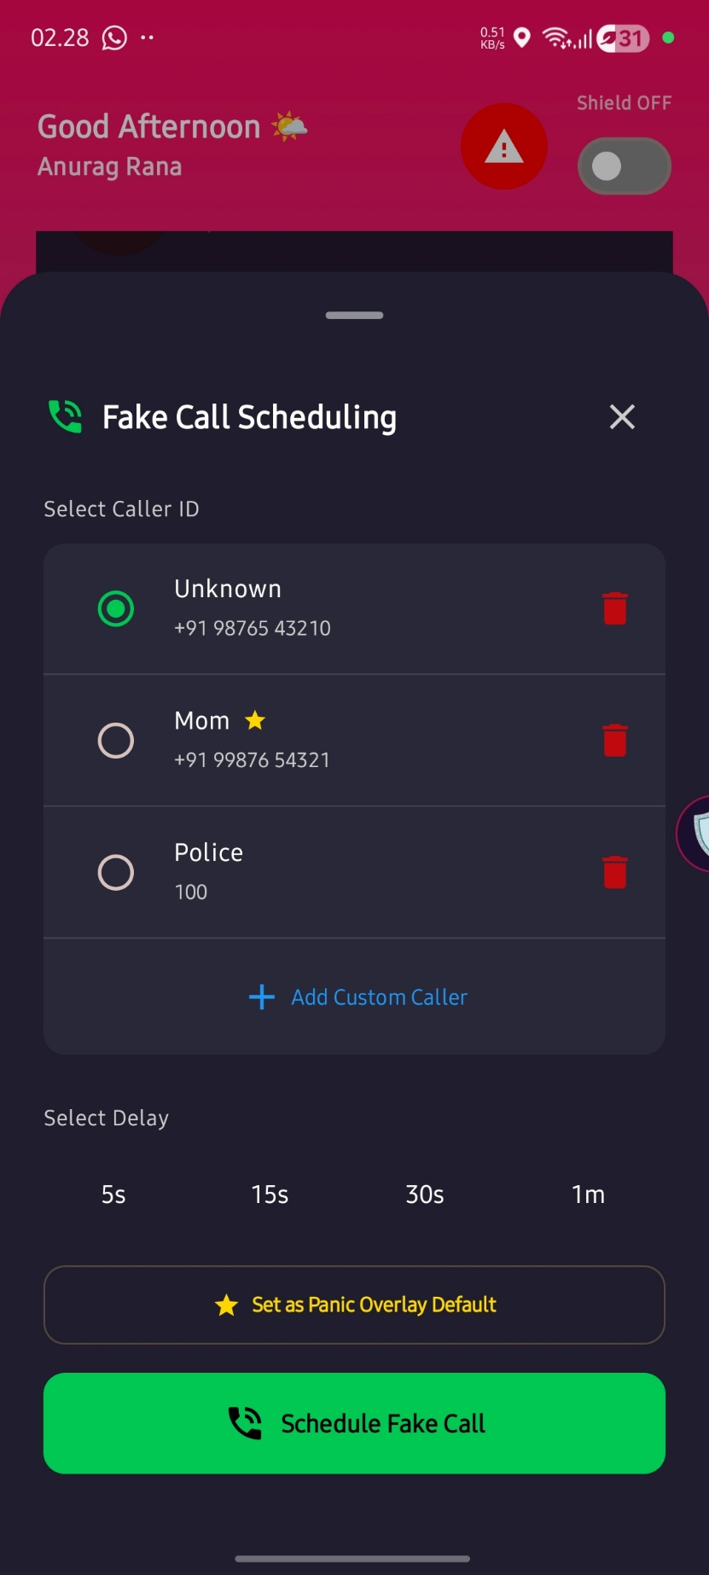 Fig 3.8.1 (Scheduling Fake Call Dialog Box) 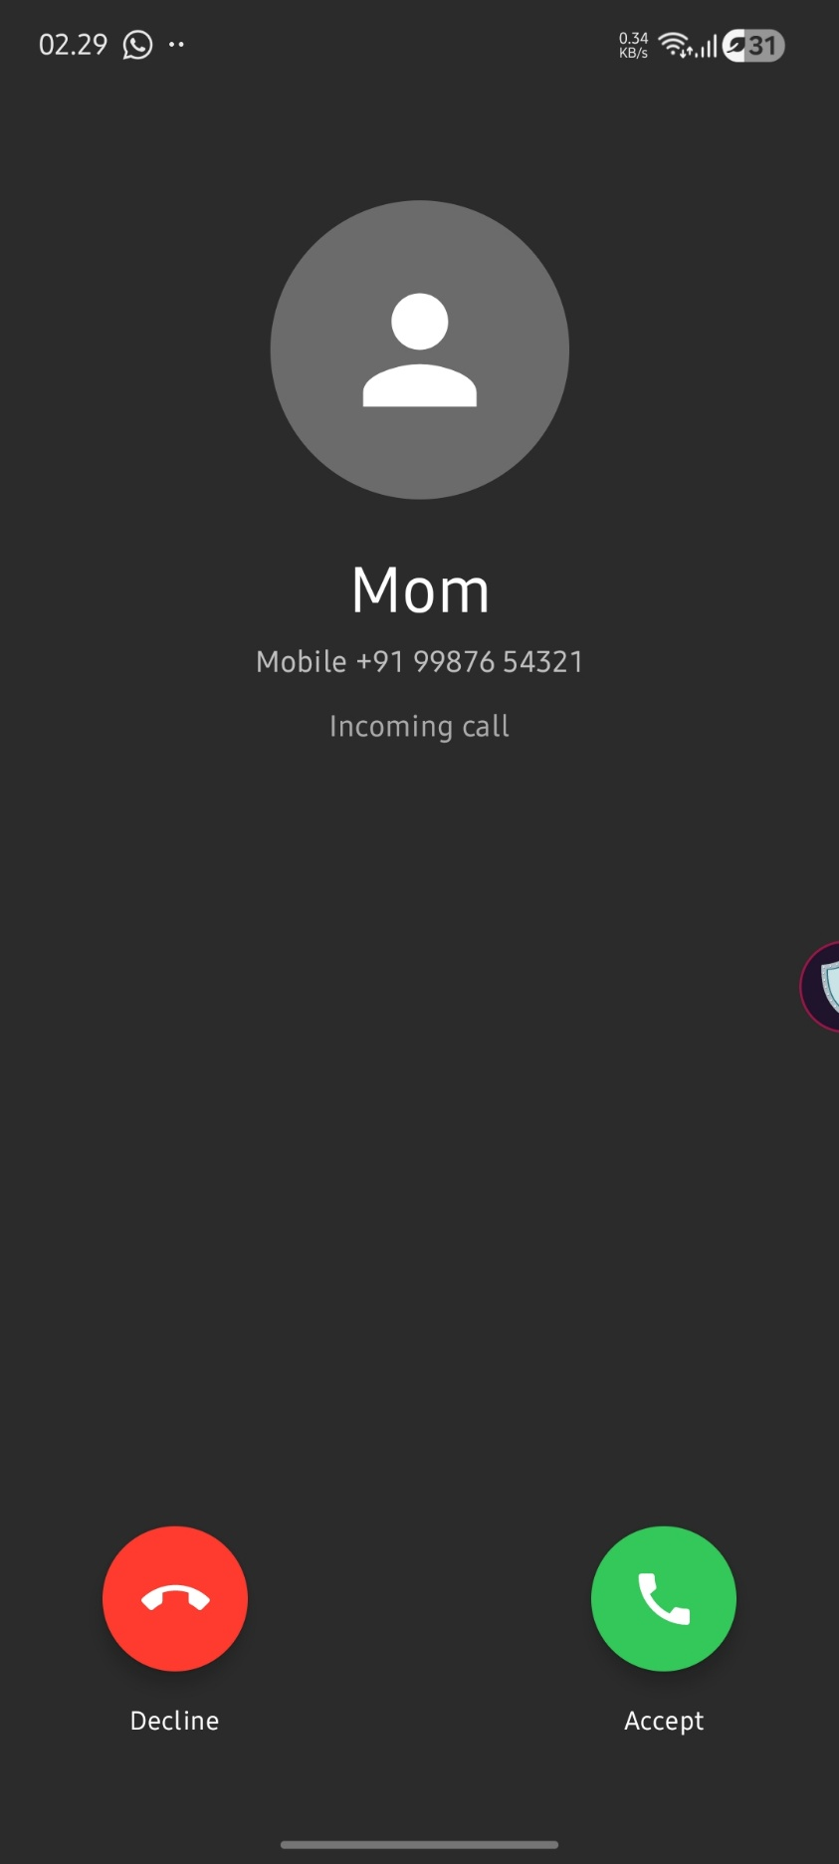 Fig 3.8.2 (Fake Incoming Call Screen) 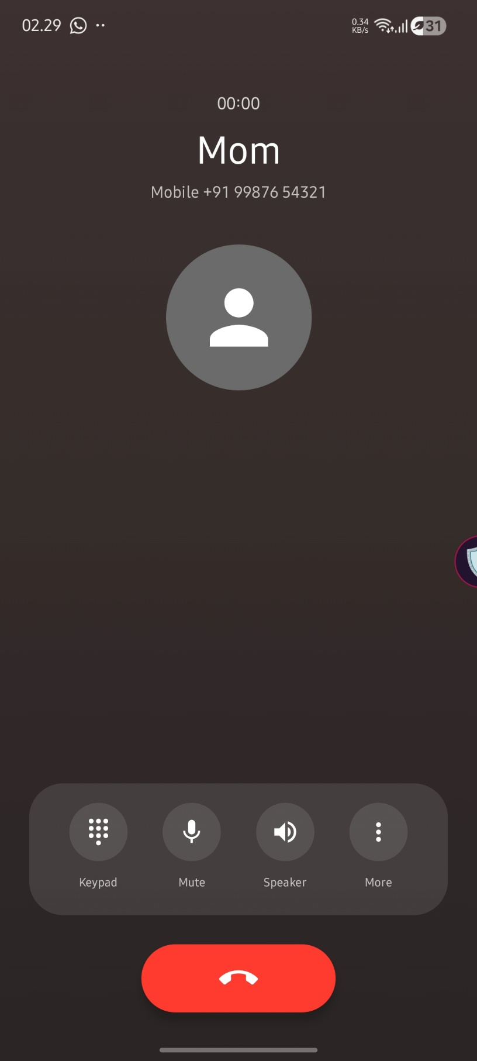 Fig 3.8.3 (Fake On Going Call Screen) 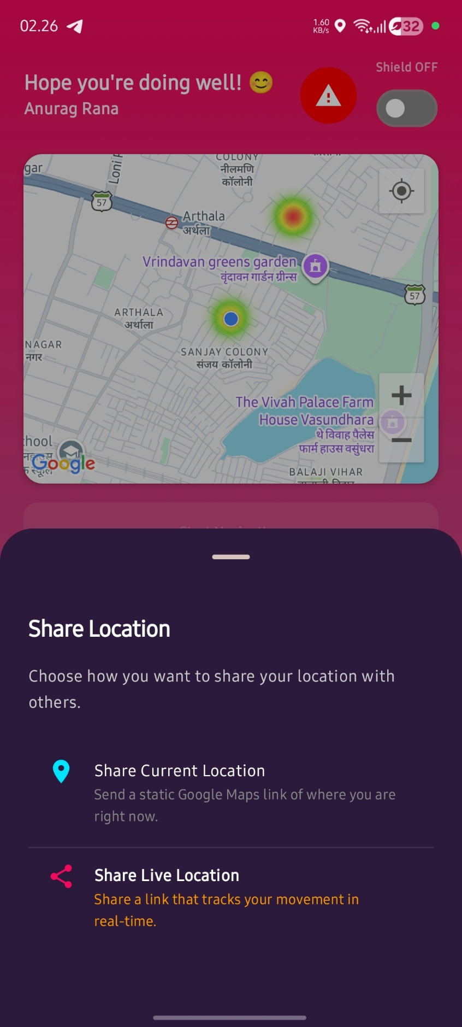 Fig 3.9.1 (Share Live OR Current Location) 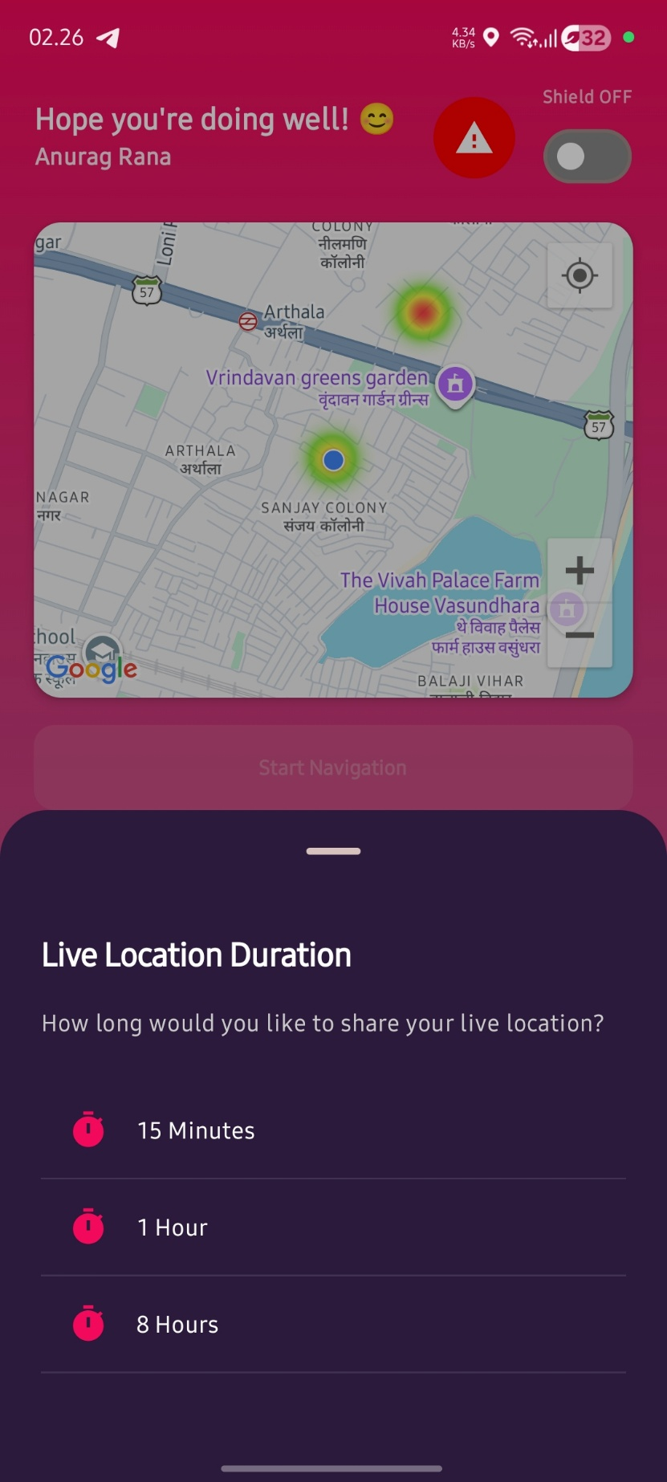 Fig 3.9.2 (Set Live Location Duration) 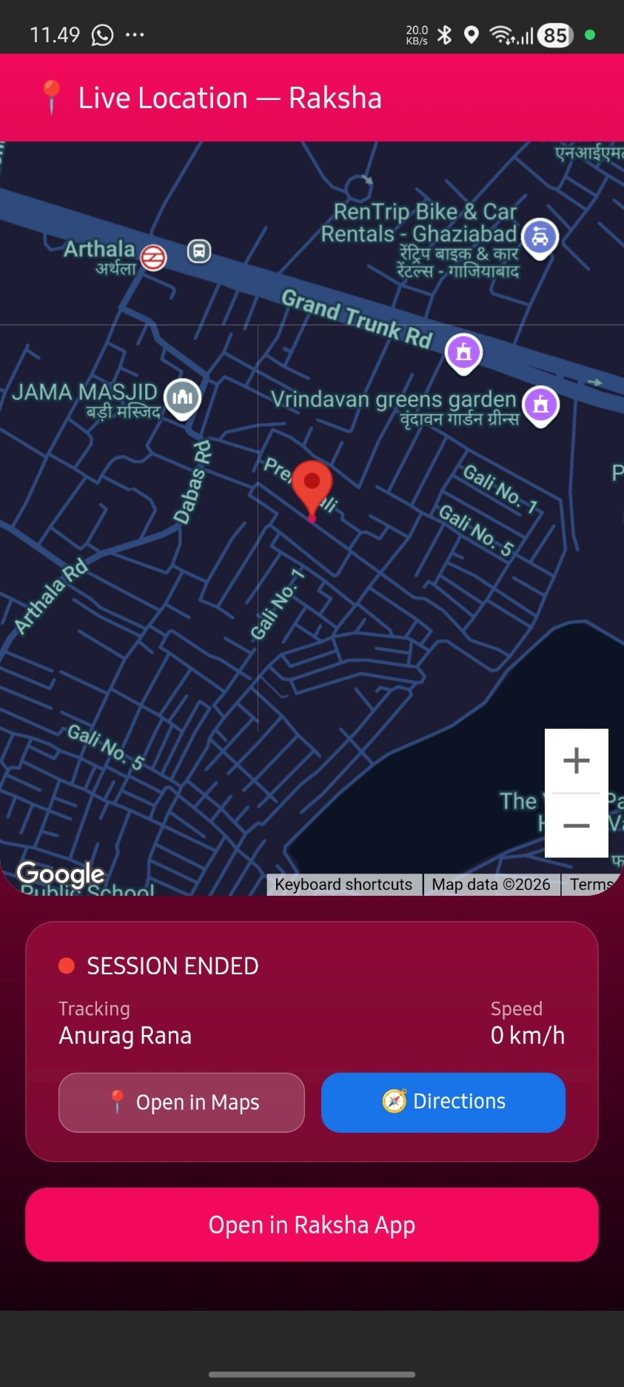 Fig 3.9.3 (Live Location Web View) 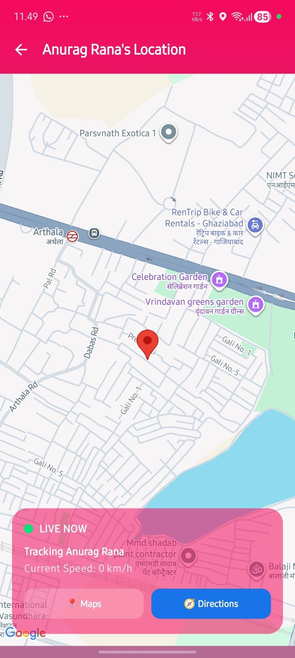 Fig 3.9.4 (Live Location In App View) 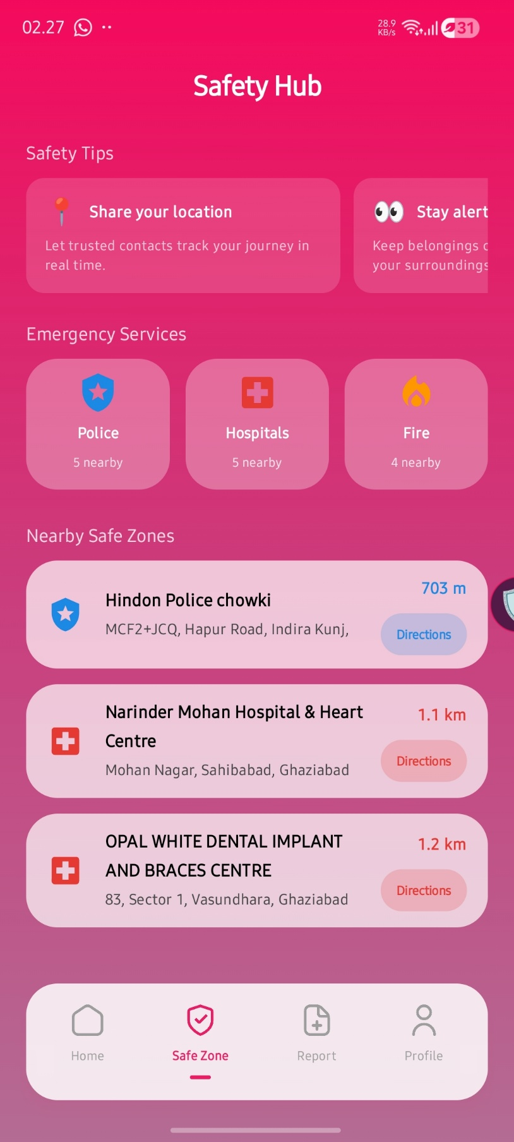 Fig 3.10.1 (Safe Zone Screen) 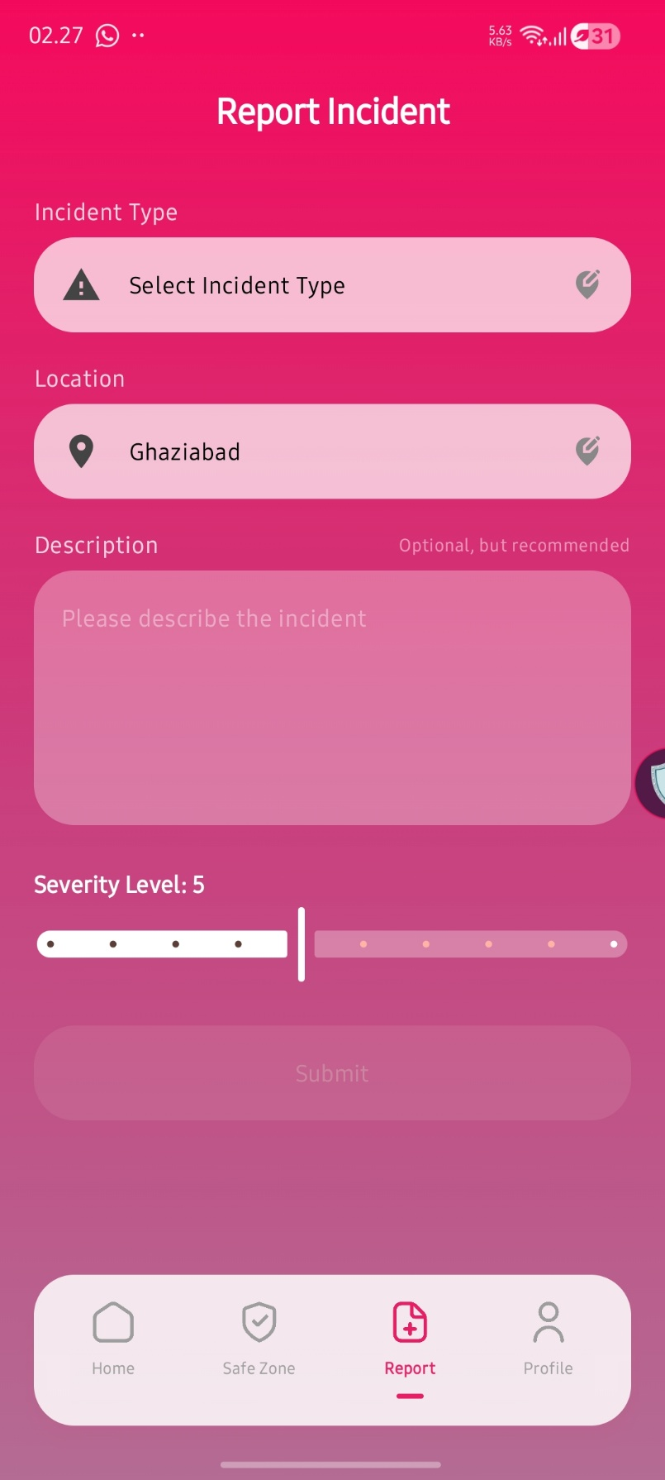 Fig 3.11.1 (Reporting Screen) 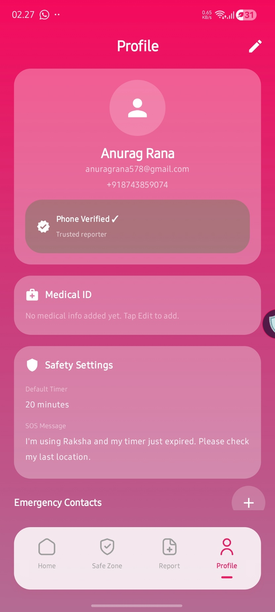 Fig 3.12.1 (Profile Screen Part - 1) 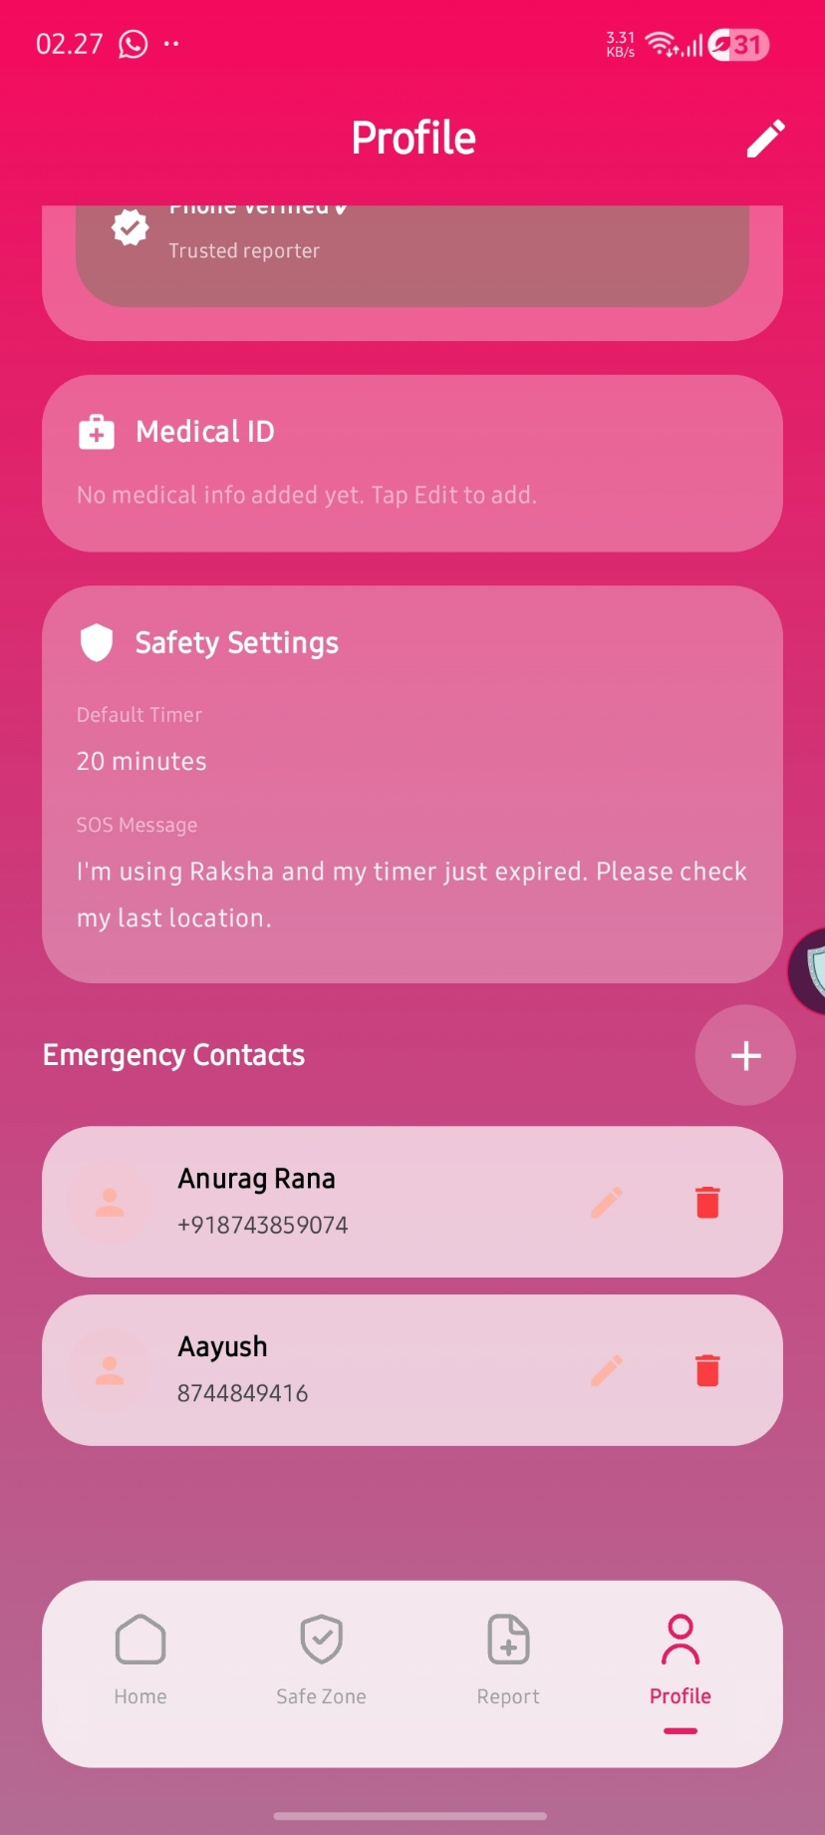 Fig 3.12.2 (Profile Screen Part - 2 ) 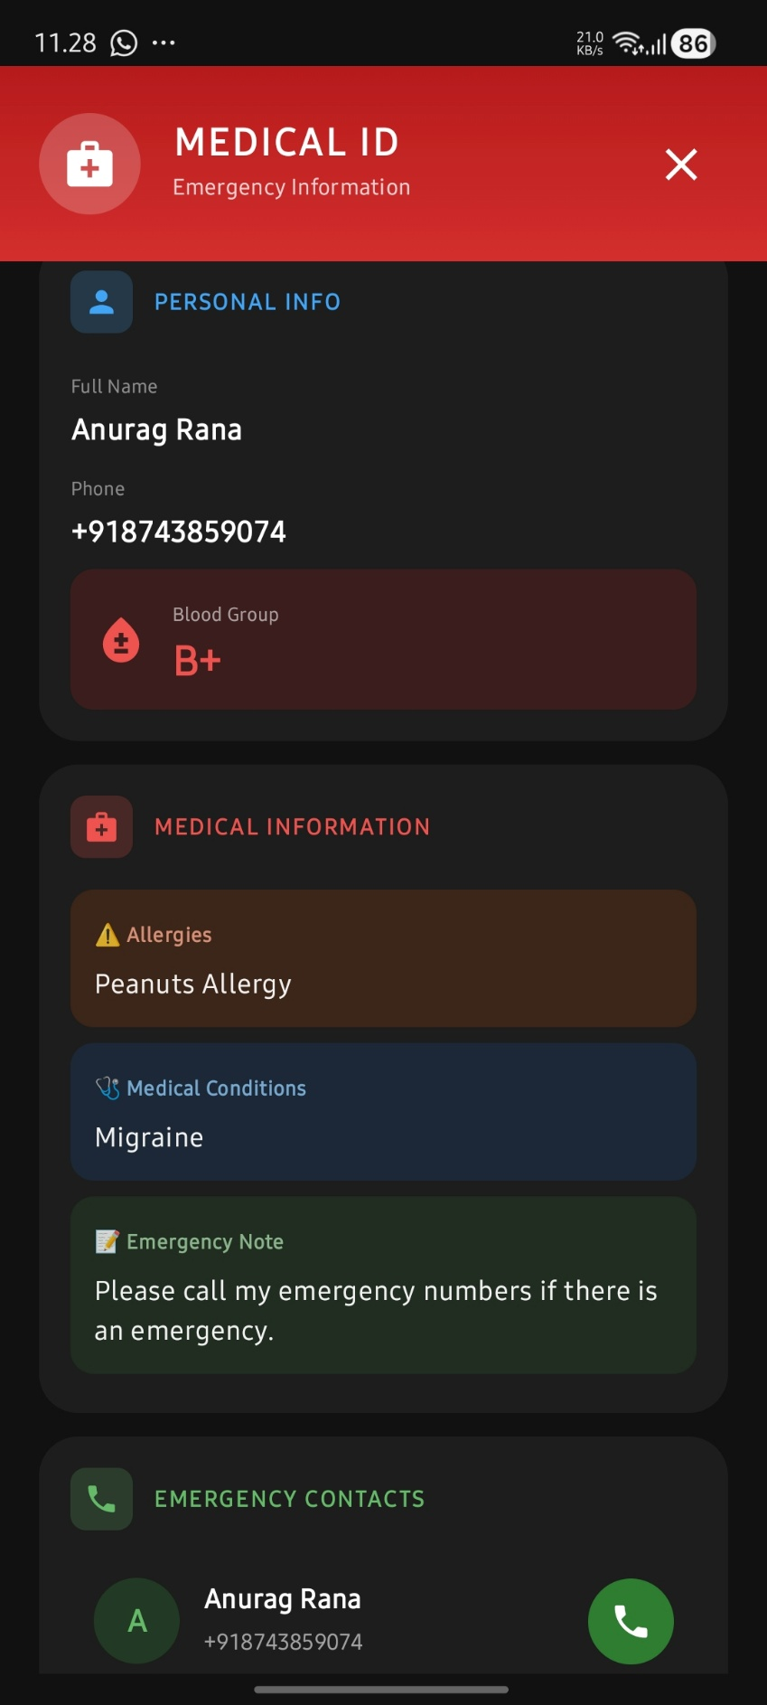 Fig 3.12.3 (Medical ID Screen) 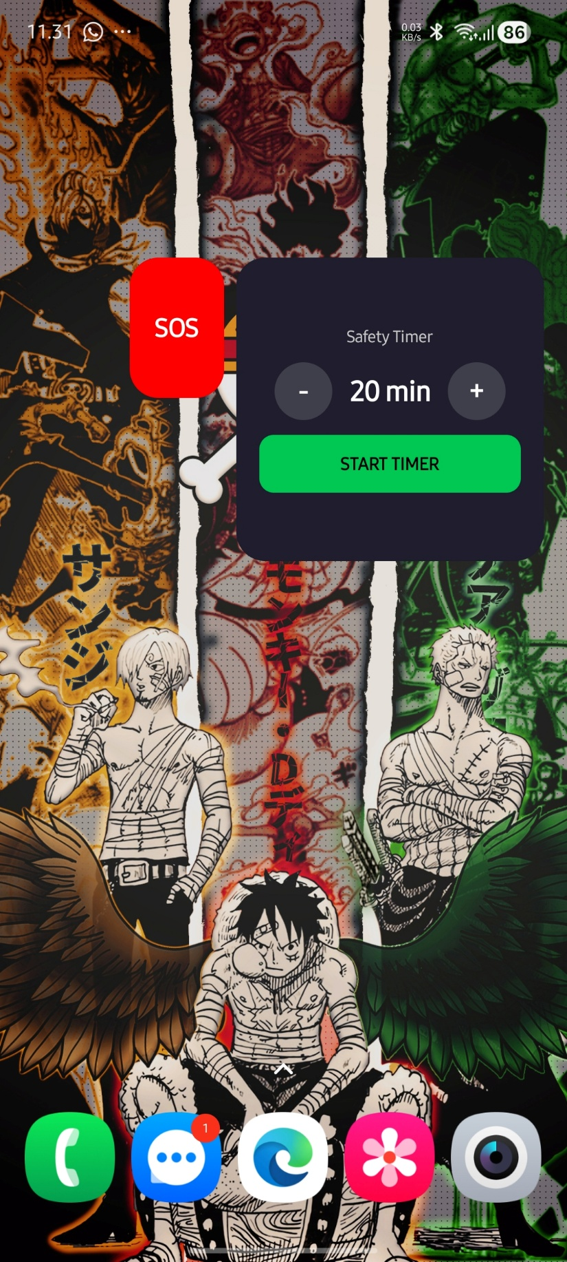 Fig 3.13.1 (SOS & Safety Timer Widgets)  Fig 3.14.1 (Raksha Panic Overlay)

CHAPTER IV: TESTING

ABOUT THE TECHNOLOGY USED
The testing strategy leverages a modern toolset to ensure code quality across all layers of the architecture:
- JUnit 5: Used for local unit testing of the Domain and Presentation (ViewModel) layers.
- MockK/Mockito: Used to create mock objects for repositories and data sources to test Use Cases and ViewModels in isolation.
- Firebase Local Emulator Suite: Used for integration testing. This allows tests to run against a local, offline version of Firebase Authentication and Firestore to validate data flows without an internet connection.
- Jetpack Compose Test: Used for UI testing, allowing the test harness to find composables, simulate user clicks, and assert the UI state.

TESTING
    - UNIT TESTING
Unit tests were performed on individual classes to verify their logic.
      - ViewModel Test: Tested ReportIncidentViewModel by calling onSeverityChange(8f) and asserting that the ViewModel's stateflow correctly updated to a value of 8.
      - Use Case Test: Tested GoogleSignInUseCase by providing a mock AuthRepository that returned a Result.Success and asserting that the use case also returned Result.Success.

INTEGRATION TESTING
Integration tests were performed to verify the interaction between different layers.
      - Auth Flow Test: An instrumented test was written to simulate a Google Sign-In. The test verified that the AuthRepositoryImpl correctly received the token, communicated with the (emulated) Firebase Auth, and returned a success, which was then correctly processed by the AuthViewModel.
      - Reporting Flow Test: A test was written to call ReportIncidentViewModel.onSubmitReport(). The test then queried the Firebase Emulator to assert that a new document was successfully created in the reports collection.

SYSTEM TESTING
End-to-end manual testing was conducted to validate the complete application flow.
- New User Flow: (Pass) User successfully navigated through Onboarding, logged in via Google, and landed on the Main Screen.
- Report Incident Flow: (Pass) Verified user successfully submitted an incident report, and the new pin was visible on the map.

- Timed SOS Flow (Failure Case): (Pass) User started a timed check, let the timer expire, and the system successfully sent an SOS alert to the designated emergency contact.
- Offline SOS Flow: (Pass) Device was set to airplane mode, user triggered SOS. Local SMS was sent immediately. After re-enabling network, WorkManager successfully delivered the Firestore SOS alert document, triggering the Cloud Function and Twilio SMS dispatch.
- Panic Overlay Flow: (Pass) User enabled the overlay from Settings. The floating button appeared on top of all apps. Long-press triggered SOS successfully. Tap expanded sub-menu for Fake Call and Location Share. Dragging repositioned the button correctly.
- Fake Call Flow: (Pass) User scheduled a fake call with a 10-second delay from the trigger sheet. The BroadcastReceiver fired the full-screen FakeCallActivity on time. The call simulation displayed correctly on the lock screen with accept/decline buttons.
- Live Location Sharing Flow: (Pass) User started a 30-minute live location session. A shareable link was generated. The viewer screen (accessed via deep link) displayed the real-time polyline trail on Google Maps. Session auto-expired after the set duration.
- Proximity Alert Flow: (Pass) During navigation, the user approached a reported danger zone. Alerts were received at the correct distance tiers: informational at 500m, warning at 200m, and urgent with vibration at 100m. No duplicate alerts were sent for the same zone.
- SOS Widget Flow: (Pass) The Jetpack Glance SOS widget was placed on the home screen. Tapping initiated the 5-second countdown (5→4→3→2→1). Tapping again during countdown successfully cancelled it. Letting the countdown complete triggered SOS via SosManager.
- Timer Widget Flow: (Pass) The Timer widget allowed adjusting duration (5-120 min in 5-min increments). Starting the timer correctly wrote to Firestore and launched TimerService. The Cloud Function scheduled the Cloud Task at the correct expiry time.
- Safe Zone Finder Flow: (Pass) The Safe Zone screen displayed nearby police stations, hospitals, and fire stations within 5km using the Google Places API. Each result showed name, address, and distance.
- Medical ID Flow: (Pass) User stored blood group, allergies, and medical conditions in their profile. The Medical ID was accessible via a persistent notification visible on the lock screen.
- Cloud Tasks Timer Enforcement: (Pass) A timer was started and the device was powered off before expiry. The Cloud Task fired at the scheduled time, the sendEmergencyAlert function verified isCanceled=false, and dispatched Twilio SMS and FCM push notifications to all emergency contacts.

CHAPTER V: ADVANTAGES AND LIMITATIONS OF THE DEVELOPED SYSTEM

ADVANTAGES OF DEVELOPED SYSTEM
    - Proactive Safety: The app's primary advantage is its proactive nature, helping users avoid danger rather than just reacting to it.
    - Automated Safety Net: The server-side Timed Safety Check provides a robust fail-safe that works even if the user's phone is disabled or out of service.
    - Community-Driven Data: Safety data is real-time and dynamic, reflecting current neighborhood conditions more accurately than static crime statistics.
    - High Scalability & Low Cost: Built on the serverless Firebase platform, the app can scale to millions of users with low operational costs.
    - Modern & Maintainable: The use of Kotlin, Jetpack Compose, and Clean Architecture makes the codebase robust, testable, and easy to maintain.
- Offline SOS Resilience: The WorkManager-backed SOS queue ensures emergency alerts are eventually delivered even during complete network outages, with automatic retry when connectivity is restored.
- System-Level Panic Access: The floating overlay provides instant access to SOS, Fake Call, and Location Share from any screen without needing to open the app, critical in time-sensitive emergency situations.
- Server-Side Safety Enforcement: Google Cloud Tasks ensures the Safety Timer's SOS is dispatched even if the user's phone is powered off, stolen, or out of service — a critical fail-safe.
- Dual-Channel SMS Delivery: Combining local Android SmsManager with cloud-triggered Twilio SMS provides redundant message delivery paths for maximum reliability.
- Home Screen Quick Access: Jetpack Glance widgets allow users to trigger SOS or start a Safety Timer directly from the home screen with zero app navigation.
- Realistic Escape Mechanism: The Fake Call simulator provides a convincing exit strategy for uncomfortable situations, with full lock-screen support and customizable caller identity.
- Real-Time Proximity Intelligence: Haversine-based proximity alerts provide graduated warnings (500m, 200m, 100m) as users approach reported danger zones during navigation.

LIMITATIONS OF DEVELOPED SYSTEM
    - Partial Internet Dependency: While the offline SOS failsafe (WorkManager) mitigates network issues for emergency alerts, core features like map display, route fetching, danger reports, and live location sharing still require an active internet connection.
    - Cold Start Problem: The app's routing feature is not effective in new areas until a critical mass of user-submitted reports is achieved.
    - Battery Consumption: Continuous GPS use for navigation and location tracking is battery-intensive.
    - Platform Limitation: The application is currently developed only for the Android platform, excluding iOS users.
    - Data Integrity: The system relies on SMS verification to build trust, but a determined malicious user could still submit false reports.
- Overlay Permission Complexity: The Panic Overlay requires the SYSTEM_ALERT_WINDOW permission, which must be granted manually through system settings on most devices, creating a friction point in user onboarding.
- Battery Impact of Multiple Services: Running multiple foreground services simultaneously (Timer, ProximityAlert, LiveLocation, PanicOverlay) can have a cumulative impact on battery consumption.
- Exact Alarm Restrictions: Android 12+ restricts exact alarm scheduling (SCHEDULE_EXACT_ALARM), requiring the Fake Call feature to use a Handler.postDelayed fallback which is less precise.
- Firestore Geo-Query Limitations: Firestore lacks native geospatial indexing. The bounding-box approximation for danger zone queries requires client-side longitude filtering, which may be less efficient at scale.

1. Enhanced User Safety
RAKSHA prioritizes safe routes over shortest routes by analyzing crime data, lighting conditions, and crowd density.
This reduces the risk of traveling through unsafe or isolated areas.

2. Real-Time Risk Alerts
The app provides instant notifications when a user enters a danger zone, faces traffic issues, or deviates from the safe route.
Helps users take immediate action and stay alert.

3. Emergency SOS Feature
In case of danger, users can activate the SOS button, which:
- Sends live location
- Alerts emergency contacts
- Enables continuous tracking
Provides quick response during emergencies.

4. Intelligent Route Selection
Using AI and smart algorithms, RAKSHA calculates a safety score for each route.
Ensures users always get the most secure path available.

5. Night Travel Safety
The app specially considers night-time risks, such as:
- Poor lighting
- Low population areas
Makes it safer for users traveling late at night.

6. Live Location Sharing
Users can share their real-time location with trusted contacts.
Family or friends can track the journey and ensure safety.

7. Data-Driven Decision Making
RAKSHA uses:
- Crime reports
- Traffic data
- User feedback
Provides accurate and reliable safety analysis.

8. Alternative Safe Routes
If the current route becomes unsafe, the app suggests alternative safer routes.
Ensures continuous safety during the journey.

9. User-Friendly Interface
The app is designed with a simple and intuitive interface.
Easy for all users, including beginners and non-technical people.

10. Continuous Monitoring
RAKSHA continuously tracks user movement and environment.
Provides ongoing protection throughout the journey.

11. Feedback-Based Improvement
Users can report unsafe areas and give feedback.
helps improve system accuracy over time.

12. Social Impact
RAKSHA contributes to:
- Safer cities
- Increased awareness
- Better urban planning (future scope)
Makes it beneficial for society as a whole.

RAKSHA is more than a navigation app—it is a complete safety solution that combines technology, real-time data, and intelligent decision-making to provide secure, reliable, and user-friendly travel assistance.

CHAPTER VI: CONCLUSION AND SUGGESTIONS FOR FURTHER WORK

CONCLUSION
The "Raksha" project successfully delivers a comprehensive, production-ready solution to the persistent problem of personal safety in urban environments. The application integrates seven core safety modules — Emergency SOS with dual-channel delivery and offline resilience, a Safety Timer with server-side Cloud Tasks enforcement, Proximity Alert intelligence during navigation, a system-level Panic Overlay for instant access, real-time Live Location Sharing with deep-linkable sessions, a Fake Call escape mechanism, and Crowd-Sourced Danger Reporting with route safety scoring — into a unified, modern Android platform. Supplementary features including Safe Zone Finder, Home Screen Widgets (Jetpack Glance), Medical ID, and context-aware safety tips further enhance the user experience. Built on a robust stack of Kotlin, Jetpack Compose, Firebase, Google Cloud Tasks, Twilio, and Clean Architecture (MVVM), the resulting codebase of 62+ source files across 15 packages demonstrates a high-quality, maintainable, and scalable safety application.

The RAKSHA application represents an innovative approach to personal safety that goes beyond simple navigation. By combining proactive danger avoidance (safe routing, proximity alerts, safety timer) with reactive emergency mechanisms (SOS with offline failsafe, panic overlay, fake call), and community intelligence (crowd-sourced reports, route safety scores), the app provides a comprehensive safety ecosystem. The dual-channel SOS delivery (local SMS + Twilio), server-side timer enforcement via Cloud Tasks, and WorkManager offline resilience ensure that safety-critical features remain reliable even under adverse conditions.
By integrating technologies such as GPS, AI, real-time data analysis, and alert systems, the app ensures that users are continuously informed about their surroundings and potential risks. Features like danger alerts, live tracking, and SOS emergency support enhance the reliability and effectiveness of the system.
Overall, RAKSHA provides a smart, secure, and user-friendly platform that not only improves travel safety but also contributes toward building a more aware and safer society.

SUGGESTIONS FOR FURTHER WORK
While the current system is a robust foundation, its potential can be significantly expanded. Future work could include:
    - Cross-Platform iOS Companion: Developing an iOS companion application for emergency contact recipients, allowing them to view live location sessions and receive push notifications across platforms.
    - Integration of Official Data: Augmenting crowdsourced reports by integrating official public police data feeds (e.g., crime statistics).
    - AI/ML Route Analysis: Implementing a machine learning model to weigh factors like time of day and historical data to generate more intelligent route suggestions.
    - Live Location Sharing ("Walk With Me"): Adding a feature that allows a user to temporarily share their live location with a specific contact.
- Offline Maps and "Safe Zone" Caching: Caching safety data for a user's local area to provide limited functionality when their internet connection is unstable.
- ML-Based Anomaly Detection: Using accelerometer and gyroscope sensor data to detect falls, sudden stops, or erratic movement patterns and automatically trigger SOS alerts.
- Geofencing: Implementing automated alerts when the user enters or leaves user-defined safe zones, such as home, workplace, or school boundaries.
- End-to-End Encryption: Encrypting location data in transit and at rest for enhanced privacy, especially for live location sessions.
- Community Features: Adding anonymous safety ratings for areas, walking buddy matching, and verified community watch groups.
- Adaptive Battery Optimization: Implementing GPS polling frequency adjustment based on user speed and activity recognition to reduce battery consumption.
- Accessibility Enhancements: Adding voice-activated SOS, comprehensive screen reader optimization, and haptic feedback patterns for hearing-impaired users.

1. Improve Data Accuracy & Reliability
The effectiveness of RAKSHA depends heavily on the quality of data (crime reports, traffic updates, etc.).
- Integrate verified government crime databases
- Use real-time crowd-sourced data from users
- Regularly update datasets to avoid outdated information
This will ensure more accurate safety predictions and route suggestions.

2. Enhance User Interface (UI/UX)
A simple and intuitive interface is crucial for user adoption.
- Use clear icons and color-coded safety indicators
- Provide easy navigation flow for all age groups
- Add dark mode for night usability
This improves user experience and accessibility.

3. Optimize for Low Connectivity
Many users may travel in areas with weak internet.
- Implement lightweight data processing
- Use cached maps and routes
- Provide limited offline functionality
Ensures the app works reliably even in rural or low-network areas.

4. Strengthen Security & Privacy
Since the app deals with sensitive location data:
- Use end-to-end encryption
- Secure user authentication (OTP/2FA)
- Allow users to control data sharing permissions
Builds trust and protects user data.

5. Multi-Language Support
To make the app accessible to a wider audience:
- Add support for regional languages
- Provide voice instructions in multiple languages
Makes the app more inclusive and user-friendly.

6. Performance Optimization
- Reduce app loading time
- Optimize backend response speed
- Improve battery efficiency during GPS tracking
Ensures smooth and efficient performance.

Future Work
1. Advanced AI-Based Risk Prediction
- Use machine learning models to predict unsafe situations before they occur
- Analyze patterns like time, location, and past incidents
Makes the app proactive instead of reactive.

2. Integration with Government & Police Systems
- Direct connection with law enforcement databases
- Real-time alerts from police systems
Enables faster emergency response and accurate data.

3. Voice Assistance & Smart Alerts
- Voice-guided navigation
- Audio warnings like: “Unsafe area ahead”
Useful for hands-free and distraction-free usage.

4. Wearable Device Integration
- Connect with smartwatches or fitness bands
- Quick SOS trigger from wearable devices
Enhances accessibility during emergencies.

5. Full Offline Mode
- Pre-download maps and safety data
- Provide basic routing without internet
Useful in remote or network-free areas.

6.safety network.
Community-Based Reporting System
- Users can report:
  - Unsafe areas
  - Suspicious activity
- Ratings for route safety
Creates a collaborative safety network.

7. AI-Based Image & Video Analysis (Advanced)
- Analyze surroundings using camera
- Detect unsafe situations automatically
Adds an extra layer of intelligent safety detection.

8. Integration with Smart Vehicles (Future Scope)
- Connect with car systems
- Provide safety alerts directly on vehicle dashboard
Useful for drivers and long-distance travelers.

9. Environmental & Weather Integration
- Include weather conditions like fog, rain, etc.
Helps avoid dangerous environmental situations.

10. Expansion to Smart City Ecosystem
- Integration with smart city infrastructure
- Use IoT sensors for real-time monitoring
Makes RAKSHA part of a larger smart safety network.

REFERENCES

Google. (2023). Firebase Documentation. Retrieved from https://firebase.google.com/docs
Google. (2023). Jetpack Compose. Retrieved from https://developer.android.com/jetpack/compose
Martin, R. C. (2017). Clean Architecture: A Craftsman's Guide to Software Structure and Design. Prentice Hall.
Safetipin. (2023).
Twilio. (2024). Twilio Programmable SMS Documentation. Retrieved from https://www.twilio.com/docs/sms
Google. (2024). Google Cloud Tasks Documentation. Retrieved from https://cloud.google.com/tasks/docs
Google. (2024). Jetpack Glance Documentation. Retrieved from https://developer.android.com/jetpack/compose/glance
Google. (2024). WorkManager Documentation. Retrieved from https://developer.android.com/topic/libraries/architecture/workmanager
Google. (2024). Google Places API Documentation. Retrieved from https://developers.google.com/maps/documentation/places
Google. (2024). FusedLocationProviderClient. Retrieved from https://developers.google.com/android/reference/com/google/android/gms/location/FusedLocationProviderClient
Google. (2024). Firebase Cloud Functions Gen 2. Retrieved from https://firebase.google.com/docs/functions
Google. (2024). Jetpack DataStore Documentation. Retrieved from https://developer.android.com/topic/libraries/architecture/datastore

